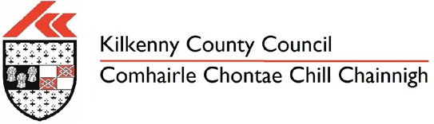
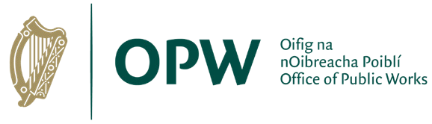
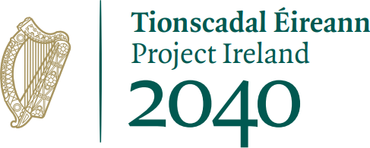

Queries
Comments or queries on the scheme can also be sent to Kilkenny County Council:
Post to: Emir Slattery, Flood Relief Capital Office, The Lodge, County Hall, Kilkenny.
Email to: ballyhalefrs@kilkennycoco.ie

As the scheme develops we will hold a public consultation day following Public Health Guidance and Social Distancing requirements at that time and there will be further opportunities to comment once a preferred option is established.

