Waterford to New Ross Greenway at Aylwardstown

SCREENING FOR APPROPRIATE ASSESSMENT

Planning Department
Kilkenny County Council
January 2018

INTRODUCTION

Waterford to New Ross Greenway at Aylwardstown
The Waterford to New Ross Greenway was placed on public display from the 9th of December 2016 to Friday the 27th of January 2017. A Screening for Appropriate Assessment (Screening for AA) was placed on display as part of the Waterford to New Ross Greenway project. This AA Screening report covers the location at Aylwardstown which is the subject of this revised part 8 application.
Material Alterations to the Waterford to New Ross Greenway at Aylwardstown are proposed by Kilkenny County Council. These alterations have arisen having regard to submissions received during the public display period for the Waterford to New Greenway part 8 application currently under consideration by Kilkenny County Council.
This Part 8 planning process refers to a short section of the overall Greenway which was to be diverted onto a local road at Aylwardstown to avoid passing in close proximity to a working farm. The section of the route now comprises 660 metres in length and will begin on the railway line at CH 11+900 adjacent to the railway under bridge UBJ443 at local road LP 7515-19 at Aylwardstown. The route continues along the disused railway line adjacent to farm holdings to the level crossing, also at Aylwardstown, where a private laneway off local road no. L-7516-9, crosses the railway line at CH 12+500.
In accordance with requirements of the Planning and Development Act 2000 (as amended), this report provides the assessment of the Waterford to New Ross Greenway at Aylwardstown and screening of same.
1.2 Description of Development
The development of the disused railway line on lands at Aylwardstown, Glenmore as a cycle and pedestrian route measuring approx 660meters in length as shown in site layout plan drawing which accompanies the part 8 application. This section of proposed Greenway forms part of a larger proposed Greenway of some 22 km following the disused railway line, extending from Ferrybank, South Kilkenny to New Ross, Co. Wexford.
The works proposed at Aylwardstown include the following:
- The clearance of vegetation on the rail line corridor, retaining boundary hedgerows and boundary vegetation
- The lifting of the old rails.
- The laying of a 3 metre wide bituminous surface on a crushed stone base to form the cycle and footpath track
- Accommodation works consisting of screen walls, screen fencing, security fencing, agricultural crossings to facilitate landowners
- Repair and upgrade of existing drains
- The marking of the aforementioned cycle and footpaths
- The upgrade and repair of the existing bridge so as to accommodate the cycle /pedestrian route
- The installation of barriers for the safety of Greenway users
- Stock proof fencing

2. NATURA 2000 SITES
Note: European Natura 2000 sites include SAC’s, cSACs, SPA’s and pSPA’s, but not NHA’s.
This stage 1 screening assessment covers Natura 2000 sites within 15km of the site development boundary which includes the following:-
- Lower River Suir Special SAC (site code 002137) (approximately 8km away)
- River Barrow and River Nore SAC (Site Code 002162) (approximately 340metres away)

The closest SAC, which is the River Barrow and River Nore SAC is located approx. 340metres away from proposed development which is protected under the Habitats Directive as a European Natura 2000 site.
Figure 1 shows the location of proposed development at Aywardstown in the context to context to Natura 2000 Sites zone of impact.

Figure 1 Location of Proposed development in the context to Natura 2000 Sites zone of impact
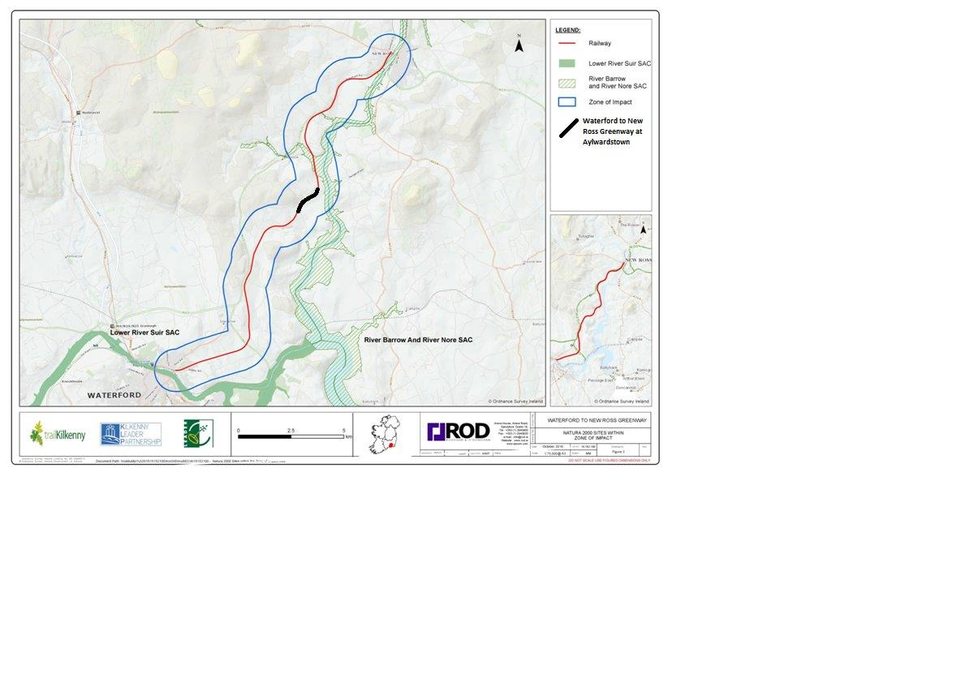

3 Proposed Assessment
Likely effects on the Natura 2000 site to be considered are
Impact Type | Significance Indicator | Likely Effect
Loss of Habitat | Percentage of loss | Not anticipated
Disturbance | Duration or permanence, distance from site | Not anticipated
Water Quality | Relative change in key indicative chemicals or other elements | Not anticipated
Fragmentation | Duration or permanence, level in relation to original extent | Not anticipated
Species population density | Timescale for replacement | Not anticipated
Water resource | Relative change | Not anticipated

The River Barrow/River Nore (SAC) and Lower River Suir (SAC) has been identified as the only Natura 2000 Sites that can potentially be affected by proposed development on the Natura 2000 Network. No works for the revised section at Aylwardstown are required within any designated Natura site and there are no hydrological path connections direct or indirect from the site to any designated protected sites.
Impacts on the River Barrow/River Nore SAC and Lower River Suir SAC can be ruled out due to their distance from the site and the lack of linkages / pathways with same.
The Aylwardstown section of the Greenway will not involve any land take from any designated site nor have any indirect or direct impacts on the qualifying interests and conservation objectives of the Natura 2000 network.

A review of the proposed development has been undertaken in Table 2.1. The Planning Authority has had regard to site layout plan and description of works submitted as part of proposed development.

Table 2.1 – Assessment of likely significant effects
Ref. no | Alteration Type | Identification of Potential Impacts | Assessment of likely Significant Effects
Waterford to New Ross Greenway at Aylwardstown
1 | 660 metres in length on the railway line from CH 11+900 to CH 12+500 as a cycle and pedestrian route and associated works as described under section 1.2 above | The nature of works along the railway line are consistent with that proposed for remainder of Waterford to New Ross greenway.  The potential impact and risks of such works in the context to existing Natura 2000 sites are described under Table 2 and 3 of the Waterford to New Ross Greenway AA Screening Report. All qualifying interests as outlined in the AA Screening report have been considered. | Construction of proposed greenway on the disused railway track at Aylwardstown will not have a significant effect on the qualifying interests of the European sites as identified as the nearest European site is located approx. 340m away from this site.  No likely significant effect are anticipated.

4. In-combination effects with other plans and programmes
Cumulative impact assessment aims to identify at an early stage any possible significant in-combination or cumulative effects/impacts with other such plans or projects on the integrity of European Sites. Plans and projects with the potential to lead to cumulative impacts in combination with were addressed in the Screening for AA published with the Waterford to New Ross Greenway and an assessment in relation to each presented. It is expected that the Proposed Material Alterations as set out above, will not lead to in-combination impacts with other plans and programmes.

5. Screening and Conclusions
The likely impacts that will arise from proposed development for a small section of Greenway at Aylwardstown alone and in combination with other plans and programmes have been examined in the context of a number of factors that could potentially have a significant effect on European Sites. The proposed development has now been assessed. It is determined that no European site within 15km of the proposed development area will be adversely affected. It is also considered unlikely that hydrologically connected European sites, outside the 15km range, will be adversely affected.
It is considered that due to the distance of the proposed development from the Lower River Suir SAC and River Nore Barrow SAC and the nature of the works proposed there is no potential for significant environmental effects either alone or in combination with other plans / projects on any Natura 2000 site.
On the basis of the findings of this Screening for Appropriate Assessment of the Proposed development, it is concluded that the Waterford to New Ross Greenway at Aylwardstown will not have a significant effect on European Sites and a Stage 2 Appropriate Assessment is not required.

Ross O’Shea 11/01/2018
Executive Planner

Denis Malone 11/01/2018
Senior Planner

