The Office of Public Works (OPW) commissioned the South Eastern CFRAM study to determine locations in Ireland which may be at risk of flooding. The determined that 25 properties in Ballyhale are at risk of flooding for the current day 1% Annual Exceedance Probability (AEP) event. There is also non residential flooding such as flooding to roads and agricultural lands.

Ballyhale is within the catchment of the Little Arrigle River which is a tributary of the River Nore. Ballyhale is affected by a tributary of the Little Arrigle River called the Ballyhale River. The Ballyhale River enters the village near the church and splits into two channels either side of the church.
A number of culverts/bridges are present on the watercourse along its route through the village.

The study predicted that out of bank overland flooding occurs upstream of the village on the eastern bank of the Ballyhale River. These floodwaters flow overland across agricultural lands and into the village. Flooding is also affected by a number of undersized culvert/bridge structures on the watercourse through the village.
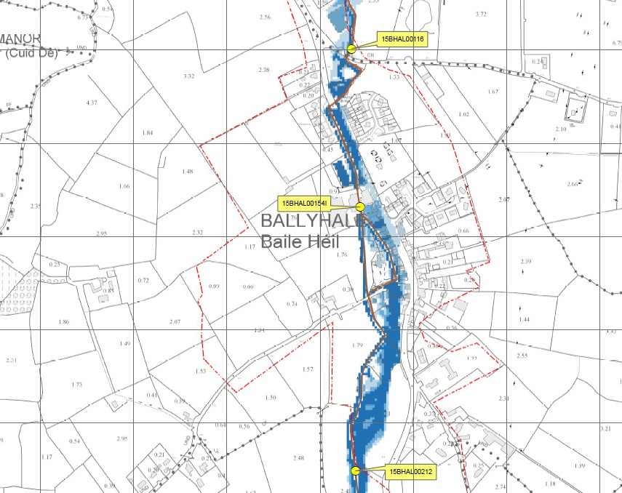
Predicted Flood Extents Map [1% AEP] (OPW Eastern CFRAM)

The study identified that a section of flood defence embankment combined with a flood diversion channel may be an appropriate way to address the flood risk.

It is noted that the diversion channel route and details shown in the previous study are a concept only and will be developed by the current design team.

