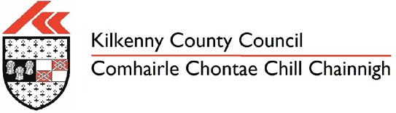
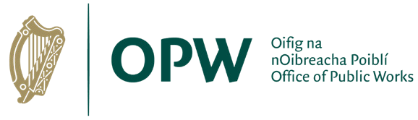
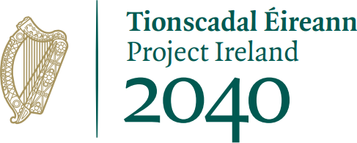
Scheme Development & Design
- Constraints Study
- Initial Consultation
- Ecological & Environmental Surveys
- Hydrologic & Hydraulic Modelling
- Topographic and Site Investigation Surveys
- Selection of Preferred Scheme Design using Multi Criteria Analysis

Planning
- Public Consultation
- Environmental Impact Assessment Report (EIAR)
- Appropriate
Assessment
- Submission of Planning Application Documents

Tender
- Preparation of Detailed Design Documents
- Incorporating Planning Conditions
- Procurement of Contractor to construct the works

Construction
- Construction of Scheme
- Environmental protection measures

Handover
- Completion of Final Snag list
- Operation and Maintenance Manual
- Handover to Local Authority
Kilkenny County Council have recently appointed DBFL Consulting Engineers to develop a sustainable flood relief scheme for Ballyhale. DBFL is an Irish owned multi-disciplinary engineering consultancy with head office located in Dublin and regional offices in Waterford & Cork cities.

The scheme is funded by the Office of Public Works (OPW).

The objective of this project is the identification, design and construction of a Flood Relief Scheme, that is technically, socially, environmentally and economically acceptable, to alleviate the risk of flooding to the Community of Ballyhale.

Stage 1
Stage 2
Stage 3
Stage 4
Stage 5

Current Stage

