Proposal for a Horse Project attached to St Catherine’s Halting Site, Kilkenny. June 2015

This proposal is for the establishment of a Traveller Horse Project in the environs of the St Catherine’s Halting Site in Kilkenny to serve the families who live on this site as well as those who have been moved to settled accommodation but who would still want to keep horses. It is being submitted as part of the Consultation on Local Economic and Community plan initiated by the Kilkenny County Council.
I make the submission under Goal 11, addressing poverty and social exclusion

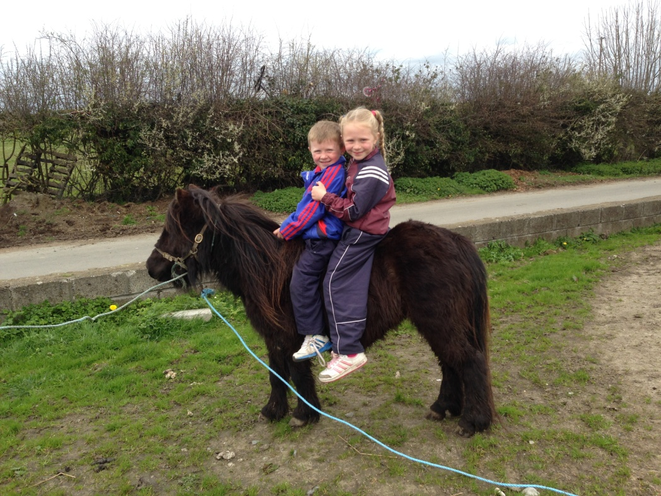

Aims of the project
- To enhance the partnership between Kilkenny County Council and the residents of St Catherine’s Halting site in order to support responsible horse ownership;

- To facilitate the keeping of horses by the residents of St Catherine’s for reasons that are cultural, social and psychological:
  - Nomadism – horses are inextricably linked to the nomadic way of life that until recently was enjoyed by the travelling community. While this has changed, the place of horses in the lives of travellers has not;
  - To recognise that the keeping of horses is inextricably linked to traveller pride and identity and therefore the mental health of, in particular, the male members of the families in St. Catherine’s;
  - To recognise that working with horses provides daily activity for men in particular who are largely excluded from the labour market;
  - To maintain the element of the culture wherein horses represent keepsakes of those generations gone before;

- To ensure that the housing project at St Catherine’s is a successful one;
- To enhance the partnership between Kilkenny County Council and the residents of St Catherine’s Halting site in order to support responsible horse ownership;
- To address issues of social exclusion;
- To facilitate the keeping of horses by the residents of St Catherine’s for reasons that are cultural, social and psychological:
  - Nomadism – horses are inextricably linked to the nomadic way of life that until recently was enjoyed by the travelling community. While this has changed, the place of horses in the lives of travellers has not;
  - To recognise that the keeping of horses is inextricably linked to traveller pride and identity and therefore the mental health of, in particular, the male members of the families in St. Catherine’s;
  - To recognise that working with horses provides daily activity for men in particular who are largely excluded from the labour market;
  - To maintain the element of the culture wherein horses represent keepsakes of those generations gone before;
- To ensure that the housing project at St Catherine’s is a successful one;
- To ensure that the welfare of horses is protected – and this would include reducing the number of horses seized, impounded and euthanized.
- To offer education and training opportunities, to both men and women, in land management, equine care and horsemanship.
- To reduce Council expense on the impounding and euthanizing of horses – in 2014, 89 horses were impounded by KK County Council, in 2013 there were 99 horses impounded, and in 2012 there were 80 horses impounded. At the moment the cost to the Council is €950.00 per horse (paid to contractor [redacted]) and therefore costs to the Council are averaging out at between 90,000 and €100,000 per year.

Background

St. Catherine’s Halting site in Kilkenny houses 10 families. In total 45 people live there in a mix of trailers/caravans and built homes. Currently 4 houses are being built on the site and a further 1 is planned. In addition, there are four families who have been moved from the site to accommodation within the city limits who would wish to be involved in the project. All the families own horses.
Unemployment in Wetlands is higher than the national average for travellers – and is over 90 percent. Please refer to The County Kilkenny Traveller Profile 2013 for additional information and background – available at http://www.kilkennycoco.ie/eng/Services/Housing/County-Kilkenny-Traveller-Profile-2013.html
The families currently have access to one acre of land opposite the site, provided by the County Council. A proposal underway now is for a number of temporary stables to be built on this site.
Attached to this proposal is Appendix 1 – the response of Pavee Point, outlining the impact of the Control of Horses Act on travellers in particular and Appendix 2 the Submission to the Kilkenny County Council re: The Control of Horses Act 1996 Draft By-Laws 2015 by members of the Carthy family resident at St Catherine’s Halting Site, Kilkenny

Proposed structure of the project

- The rental or purchase of land close to the halting site/housing project. It is envisaged that an amount of 25-30 acres minimum would be required for the project to be successful; The land at Daly’s Hill, currently in NAMA, would be ideal.
- The building of a hay shed/internal stabling unit (proposed size 12m x 36m) to include stalls for twenty horses plus a storage unit for hay, feed and tack; Following consultation the horse owners would be keen to become involved in the construction of this building, particularly in the block work required for outer and inner walls;
- Oversight of the project to be by a committee established with members drawn from the horse owners, KTCM, KLP and the County Council;
- The appointment of a part time project manager for the day to day management of the project;
- A weekly contribution by the horse owners towards the project – i.e. towards the land rental and the shelter i.e. a membership fee, as agreed to during the consultation process
- A set of conditions to be agreed to by the horse owners and those they are working with - a contract of membership;
- The facilitation of ongoing training and education;
- The possibility of a sulky racing track within the land acquired;

Costing of the Project (estimate)

Barn structure to house horses on the 1 acre site in Wetlands € 60,000 incl VAT (rough estimate from local farm shed construction company and builders)

The leasing of 27 acres adjacent to this 1 acre site (yearly cost) € 7,215
(As per the 2013 Traveller Horse Project Proposal 27@ €7,125 )

Fencing and reseeding of land, plus provision of water to paddocks € 40,000
(rough estimate )
Total Outlay €107,215

Notes:
An ongoing cost to be added to this would be the cost of a part time manager of the project. KTCM have already allocated yearly costs towards horse projects for all three halting sites in Kilkenny (150,000 per year) but I am unaware of whether this is secured funding
The construction of a horse barn/hay shed with individual stalls as well as with storage space for hay, water and feed; for this purpose we would look at a hay barn span of approximately 12m x 36m – this could contain 20 stalls 3m x 3m each plus an area for feed storage, farrier work etc. The passage between stalls would be wide and could be used for tethering horses or creating a loose barn if needed. Sliding doors at each end. To be built on the 1 acre directly opposite the halting site.

Conclusion
Minister Coveney has himself expressed interest in these kinds of projects and, apart from that, we believe that the Council could explore a number of funding sources for this, including, but not limited to, the HSE (in terms of mental health) Lotto funding, Rural development Programme and the Carlow Kilkenny Education and Training Board. A good working horse project in each of the main sites in Kilkenny (and this proposal only deals with the Wetlands halting site which is in dire need of support) would be a very positive thing for Kilkenny. And certainly more positive than horses constantly being seized and put down through [redacted] acting on behalf of the Council. I would envisage a situation where this would enable the community in Wetlands to play a positive role, with their horses, in the life of Kilkenny. A well run project would be empowering for the participants themselves as well as for members of the settled community who could see well cared for happy horses on the outskirts of the city. I believe it could go some way towards addressing the very real divide that exists in the city between the settled and the traveller communities. A divide that need not be there.
In addition this makes economic sense. If there were three working horse projects in Kilkenny the annual budget used to seize horses and put them down could be redirected towards making Kilkenny a model county in terms of horse welfare and traveller relations. It is an essential part of the project proposal that members of the horse project contribute towards the ongoing upkeep of the facilities and participate in the equine education and training. Some of the best farriers in the country are travellers yet they hardly ply their trade outside of their own communities. A structured horse project would allow for this. In addition, with young boys and girls coming up through the ranks, many of whom are natural horsemen and women, options could be explored with the racing fraternity in Kilkenny of apprenticeships towards becoming jockeys.
I believe that we need to look to the positives of this proposal, accepting that horses are an integral part of traveller culture and working with this.

APPENDIX 1

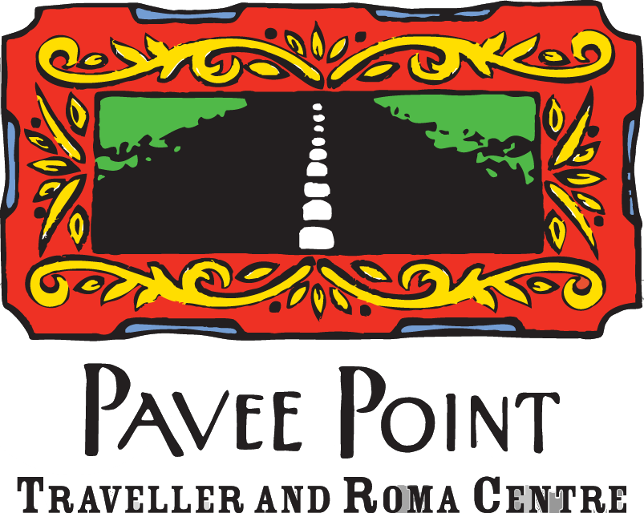

Submission on the Control of Horses Act 1996
September 2014
1. Background
In the mid 1990s, urban horses became a popular topic of debate in Ireland with ‘wandering horses’ documented across the country. The Control of Horses Act 1996 was passed to deal with the issue of wandering horses and to improve animal welfare and public safety.

Horses have always played a significant role in Traveller culture and are often depicted as part of Traveller lifestyle in works of art, poetry and songs. Further to this, horses were a core part of the Traveller economy, with Travellers trading at horse fairs and relying on the horse trade for income. Horses were also a social outlet for Travellers, maintained for sulky racing and as a hobby.

Before the passage of the Act, an advisory group was established to consider the requirements for such a Bill. No representative of the Traveller community was involved in the group.

This submission has been prepared pending an indicated review of the Control of Horses Act by the
Department of Agriculture, Fisheries and Food.

2. Horses as part of Traveller Culture
Travellers are defined in the Equal Status Acts as the “[C]ommunity of people commonly called Travellers and who are identified (both by themselves and others) as people with a shared history, culture and traditions, including, historically, a nomadic way of life on the island of Ireland.”1 In
2014, the Joint Oireachtas Committee on Justice, Defence and Equality recommended that Travellers be recognised as an ethnic minority in Ireland.2

The Traveller community has a long and rich history of keeping horses, but in many ways this is different to the horse ownership history displayed by the settled community.

a) Nomadism
In the past, horses were specifically kept by the Traveller community for the purposes of facilitating the nomadic way of life in the community. Obviously over time modern vehicles took the place of horses for this purpose, but horses remain strongly associated with the Traveller community because of their nomadic history.

b) Traveller Economy
Trading horses at horse fairs and markets has long been a core part of the Traveller economy, with many Travellers investing skill and time in caring for horses, seeing them as an investment. The Traveller economy has been dismantled over time but Travellers maintain a strong affinity with horses. The ability to breed and trade horses contributes significantly to the wider Irish economy and at one time enabled some Travellers to attain financial independence.

c) Traveller Culture and Social Outlets
Horses are often linked to Travellers in many cultural depictions developed both in Ireland and internationally and horses have long been considered part of the Traveller identity. On a social level, Travellers keep horses for entertainment purposes including sulky racing and fairs, where Travellers with similar interests gather to share experiences, not just with one another but also with members of the majority settled community. These shared experiences contribute positively to challenging
stereotypes and sharing skills.

1 Equal Status Act 2000 s.2(1)
2 Houses of the Oireachtas, Joint Committee on Justice, Defence and Equality, Report on the Recognition of Traveller Ethnicity (2014)
3. The Impact of the 1996 Act
Without question, the Control of Horses Act and the by-laws which emerged from it in local authorities had a detrimental effect on Traveller economy, culture and social pursuits. While the focus on animal welfare and public safety was broadly welcomed, Travellers’ poor accommodation status and lack of land ownership impacted on their capacity to meet the requirements of the 1996
Act. The 1996 Act definitely had a disproportionate impact on Travellers and working class communities.

a) Traveller literacy
It has been concretely established that literacy problems remain a significant struggle for members of the Traveller community in Ireland. According to the All Ireland Traveller Health Study, over 28% of Travellers express difficulty reading.3 When the 1996 Act was introduced and passed, it was a requirement that local authorities advertise the drafting of bylaws and seek submissions from interest groups. However, where advertising did occur it did not adequately reach target groups and it did not account for literacy barriers, minimising the input from Travellers in particular. This meant that the bylaws which were passed did not take into account the cultural significance of horses and the particular difficulties Travellers would face under the new Act.

b) Lack of Uniformity in Bylaws
The 1996 Act facilitated local authorities to implement bylaws in their given areas, meaning that rules could be different in different parts of the country. This impacted on Travellers who lived a nomadic lifestyle and the lack of engagement with Traveller groups to explain the new laws and bylaws presented further complications.

c) Traveller Accommodation and Renting
According to a survey circulated by the Irish Traveller Movement following the implementation of the Act4, horses remain a strong part of Traveller identity, whether in Traveller accommodation or in standard housing. Further, the survey suggested that Travellers used council land to graze horses, which left these horses open to impound and seizure, particularly when Travellers were unaware of the regulations in the Act. Travellers who answered the survey indicated that land-owners would refuse to rent to them and that land they could rent was far from where they resided.

4. Recommendations
At the Animal Welfare Conference held in Dublin Castle on May 16th 2014, Minister for Agriculture, Food and the Marine Simon Coveney TD announced a review of the Control of Horses Act 1996. The Minister noted that some local councils had excelled in implementing the Act but that others had not. The Minister requested interested groups to participate in a consultative process before the Act is reviewed.

Pavee Point is concerned that this Review is not independent of the Department and firmly believes that such a review should be independent.

3 All Ireland Traveller Health Study, (2010), Selected Key Findings and Recommendations at 10
4 Irish Traveller Movement, Report on the Socio-Economic Consequences of the Control of Horses Act 1996 on the Traveller Community at
12
1. Engagement with Traveller groups
It is evident that the 1996 Act had a tangible impact on members of the Traveller community, who had up to that point relied on horses for social networking, financial independence and cultural heritage. While we maintain support for animal welfare, licencing and microchip regulations, the current procedures must be reviewed in consultation with Traveller groups to increase awareness.

New procedures and rules must also be formulated in consultation with the Traveller community, ensuring broad understanding of regulations and building capacity within the community to make sure Travellers are able to meet the requirements on all levels.

2. National Implementation
It is clear that local implementation of the 1996 Act was not sufficiently successful. In review, the
1996 Act should be updated on a national level, implementing uniform rules and regulations across the board, particularly in relation to costs for impound and recovery.

These rules could be administered by local councils in consultation with interest groups in an advisory capacity. This system would increase cultural awareness and solve arising issues with sensitivity while also enabling a wider spread of information about incoming rules and regulations.

3. Traveller Accommodation
There remains an abundance of council land surrounding many halting sites and Traveller housing schemes in Ireland. Is it clear that provision for grazing land should be built into future Traveller accommodation plans, enabling Travellers to care for their horses in a safe space and in line with their cultural heritage of tethering horses near their homes. This would limit the use of council land for grazing and would further limit the losses incurred by Travellers whose horses are grazed a far distance from their own residences.

4. Local Traveller Partnerships
Much benefit could be had from a partnership approach between local authorities and traveller organisations in developing innovative approaches to support responsible horse ownership within the Traveller community. We recommend that funding be made available to Traveller projects to develop equine projects and husbandry skills courses.

5. Equality Proofing
All future policy developments on the Control of Horses Act and its implementation must be Traveller/equality proofed to ensure that the impact of such legislation does not continue to have a disproportionate impact on the Traveller community.

Appendix 2

Submission to the Kilkenny County Council re: The Control of Horses Act 1996 Draft By-Laws 2015 by members of the Carthy family resident at St Catherine’s Halting Site, Kilkenny

Dear Chairman of the Council and councillors,
We are members of the Carthy family who live or have lived at the St Catherine’s halting site, also known as Wetlands. We have asked Paula Leyden to prepare this submission following discussions with us on the proposed by-laws above.
We will initially address some general issues.
We would like to say at the outset that we would have appreciated it if Cllr. Andrew McGuinness had come to talk to us about these laws instead of talking to the newspapers. Even after he had done that and these by-laws were prepared he did not either come out to see us or call us in to meet with him.
It is obvious from the press releases and from the statements he made that these by-laws are aimed at the travelling community, at us. The by-laws do not contain the word traveller but the intention is clear from the statements made by Mr McGuinness who firstly set up a petition on change.org (an unusual step for the mayor of a city who has access to every means to change a law – petitions are usually used by those who lack access to political power); secondly he stated that he was introducing a motion for the drafting of by-laws that would ‘outright’ ban sulky racing. He says, in a follow up to his petition, that ‘The proposal would essentially ban Sulky Racing in Kilkenny City and County.’ Which, given the proposed legislation, it does not in fact do. What it does do is raise whole lot of other issues around the keeping of horses by our community.
If, as Cllr McGuinness states, his concern is the welfare of the horses, then we would like to suggest that he and the Council also look at the manner in which the pound is run and the cruelty issues that are raised by this. For example, pregnant mares are killed in the pound using a captive bolt and a pithing rod. What this does is kill the mare but not the foal. The foal then dies a slow and agonising death. These issues were raised with the Department of Environment within the Council last year when a number of heavily pregnant mares were impounded. We asked the Council for time to rescue these mares and allow the families to raise the money necessary to reclaim them. We were not given this time. Rescue organisations then came forward to offer homes to the mares. This was refused by the Department of the Environment officials in the Council. We would like to ask the Council to examine the welfare concerns of, in particular, pregnant mares being euthanized. We believe this should not happen.
In addition, as his concern for horses has motivated these draft by-laws, we would like him and the Council to acquaint themselves with the statistics of Irish horses that die in horse racing in Ireland, as well as in the UK, as a direct consequence of racing on the track. Some of those statistics can be found here http://www.gubbage.com/horse-racing-death-register
Perhaps both Cllr McGuinness and the Council will also look at the number of horses, in the main these are thoroughbred horses, who are sent to slaughter as they might not be good enough for racing or in the case of sport horses, not good enough for the show ring. These numbers run into thousands each year (at the height of the killing in 2012, 24,362 horses were killed).
While the Council is looking at horse welfare issues we would like them to examine all the above issues as well.

With regard to the specific points in the draft by-laws:

7 (a) We do not understand this provision as, in effect, it is meaningless once read with 7 (b) and (c). Could you clarify the purpose of this section?
7 (b) Where you state that a person can 'have a horse on a public road' does the word 'have' include keep, ride or drive as in 7 (a) above
7 (c) Could you also clarify what you mean by a bridle – does this include a bitless bridle or, if a horse is being led, a halter/headcollar?
9 (b) through to (k) We assume that this applies to all horse owners throughout the control area, i.e that every person who owns a horse in County Kilkenny with be subject to these regulations?
With respect, some of the terms used in this section are unclear and unenforceable and the opinion required on whether these standards are being met would, of necessity, be subjective. For example 9 (f) not all horses are exercised by their owners and nor do they have to be, as not all horses are ridden or driven. Some are brood mares.
We believe that this section in particular (i.e. 9 (b) through to (k) seem to belong somewhere else – in published guidelines on animal welfare for example (similar to those published by The Farm Animal Welfare Advisory Council - http://www.fawac.ie/media/fawac/content/publications/animalwelfare/AnimalWelfareGuidelineforHorsesPoniesDonkeys.pdf)
We would ask that you look at Section 9 (b) to (k), and if this is to be included that it applies to all horse owners within the county. Our request is that it not be included, because to prove an offence by pointing to a ‘breaking’ of one of these sub sections would be hard to do in an objective manner. There are as many opinions about what constitutes horse welfare as there are horse owners, some for example would believe that horses are best kept at grass and outside all year, with their feed only supplemented by hay in the winter. That to keep horses in stables for extended periods constitutes cruelty to animals. There are many stallions on the county and country who are kept in these conditions. Others would vehemently disagree with this. There is a view that keeping a horse on its own, without other horses for company, constitutes cruelty. Yet there are many such horses in Kilkenny. With respect, this section of the by-law is woolly and subjective. If there is to be a section on what constitutes horse welfare then there needs to be much wider consultation on this and if it was done correctly then the enforcement mechanisms county wide would need to be in place to ensure that ALL horse owners are subject to the by-laws.11 (a) (b) and (c) as we understand it, states that no sulky racing will take place on public roads in Kilkenny, without permission from the Council? If that is correct, we have no problem with that. In relation to the discussion below regarding an Equine Premises Number, we would in fact much prefer to race our horses on a track, but no land is available for this purpose in Kilkenny.
11. (a) - (c) This section deals with the nub of the proposed by-law (as stated publicly) and as far as we can tell the Roads Act of 1993 (Sections 74 and 75) which was in operation before the by-laws and will be in operation after the by-laws, still applies. In addition, within the previous Control of Horses Act 1996, a person in control of a horse on a public road had to be fitted with a bridle and be over 16 years of age. Perhaps you could clarify for us what difference this section of the Act brings to the table? We assume that this does not prohibit the use of sulkies on public roads?
12 (a) If notice of the seizure of a horse is only going to be served on an owner within five days of it being seized, and in the worst case scenario notice is served in the 5th day, the owner would be unable to reclaim the horse, particularly when, as is the current situation, the horses are kept [redacted] in Cork.
Also in 12 (a) If only written notice is served this would negatively affect horse owners who are unable to read. We would ask that this be changed. The same applies to 12 (b)
12 (d) Does this mean that if a horse is seized, taken to the pound and kept there for five days without being reclaimed, and it is then killed, that the Council is entitled to recoup the amount charged by the pound for this service, from the owner? Under the current situation, this would amount to approximately €980.00? Please clarify this. If this does mean this then we would reject this section.
12 (e) raises a set of questions that we would like answers on from the Council. Within the travelling community in Kilkenny, in particular within the travelling community resident at Wetlands (St Catherine’s Halting site) we have no access to land that has an Equine Premises number (as required for the return of the horse). We have been in discussion with the Leader Project and the Council for many years now about the establishment of a horse project for our area and are pleased with the recent developments regarding the construction of stables opposite the site. On the plans this states that the paddocks are temporary, could you clarify this? We would like to take this opportunity to ask the Council about this and about progress in relation to the proposed Horse Project for Wetlands, in particular access to land? We have stated previously that we are prepared to contribute towards this project once it gets set up, in effect a membership fee.
In addition to this, there are times when we have permission to have our horses on a piece of land but do not know whether or not the owner of that land has an Equine Premises Number (as was the case when we were given permission through the Council to use [redacted] land, but that land did not have an Equine Premises Number and this was known by the Council).
The question also arises here of families who are being moved into accommodation in town where the keeping of dogs and horses is not permitted. Will these families be accommodated within the horse project?
We would ask that discussions between ourselves and the Council on a horse project, on the renting of land in particular, be reopened and a time frame put onto the start of this project. The development of a horse project for our community has been in the pipeline for many years and we appreciate the efforts put into this thus far, but in particular with this section of the proposed by-laws there is some urgency to this discussion.
12 (f) The word ‘dispose’ here is used to mean either sale or ‘destruction’. As the draft by-laws were generated by a desire to protect the welfare of the horses, how is the destruction of a horse using a pithing rod and captive bolt (as is used by [redacted]) protecting the welfare of the horse? How do you kill a horse to protect its welfare? Does the Council propose to have a policy (similar to the one being developed for the dog pound) that does protect the welfare of the horses that end up in the pound? And advisory committee that ensures that the welfare of the horses is paramount? If you do intend that, then we would suggest that this forms part of this legislation. We would, for example, want to ensure that the primary intention of the council in impounding horses is to save them, not kill them. We would like to see these by-laws reflect that welfare concern. You state in 12 (e) that you would want to ensure that the horse ‘will not be cruelly treated’. If the horse is being killed, how is this not ‘cruelly treated’?
12(j) If a horse is being sold not at a market or a public auction then the time and place of this sale will not be stated in the notice of sale. Please clarify this as it is open to abuse.
If a horse is to be sold on an open market or in any other way (not defined?) what protections are in place to ensure that those who buy the horses fulfil all the requirements set down in these laws for responsible horse ownership? Or that the permission for a private sale is not subject to abuse?
14. Our concerns here would be similar to our concerns about Section 9 – For example if an authorised person or a guard who might or might not have any equine experience, tells a horse owner that their horse has not been adequately visited so they are now in breach of the by-law, this makes no sense. We would like clarity on who the authorised person/persons might be? Are there published criteria for the selection of an authorised person?
Under the section Penalties, 16, we have some concerns.
Given the looseness of the definitions above (in 9 for example) you could have a situation where, in the opinion of an authorised person or a member of the Guards, a horse does not have enough ‘wholesome’ food. The owner of the horse would then be in contravention of the by-law, would be guilty of an offence and shall be subject to a ‘summary’ conviction and fine not exceeding €1904.00 or to imprisonment not exceeding six months. How, in anyone’s book, can this be considered fair? If you are going to have offences that attract summary conviction, fines and/or imprisonment then those offences need to be very strictly defined. The above by-laws are not and they are open to the widest interpretation.
Which brings us to our last point – what are the enforcement mechanisms for these by-laws. If you are applying these laws to all horse owners in County Kilkenny (as the control area covers the whole of County Kilkenny) are you going to have horse welfare inspectors who will go onto private land? Does this job belong to the Guards? Or, does the legislation exclude anyone who is not a traveller? If it does then we would ask you to specify that, although we might suggest that specifying it could raise issues in terms of equality legislation.
We would like to request a meeting with the Council to discuss all these matters raised above – both in relation to the draft by-laws as well as the proposed horse project. We are available at your convenience.
Kind Regards
The Carthy family
Submission prepared by Paula Leyden in discussion with members of the Carthy family

