KILKENNY LOCAL ECONOMIC & COMMUNITY PLAN (LECP)
SOCIO-ECONOMIC STATEMENT:
DRAFT HIGH LEVEL COMMUNITY GOALS.

PROFILE OF COUNTY KILKENNY
COMMUNITY DEVELOPMENT, SOCIAL EXCLUSION AND POVERTY ANALYSIS

CONTENTS PAGE NO.

- Local Economic & Community Plan (LECP)
  - Background to the LECP 4
  - The LECP Process 5
  - Overview of Kilkenny LECP 7

- Demographic Profile of Kilkenny : At County Level
  - Area Profile 8
  - Population 9
  - Age Profile 11
  - Deprivation 13
  - Unemployment 16
  - Education 19
  - Lone Parents 20
  - Housing 21
  - Homelessness 22
  - Health & Well-being 24
  - People with a Disability 24
  - Ethnic Minorities & Travellers 25

- List of Relevant Plans, Strategies & Services Reviewed 28
- Consultation Processes 31

- Framework Priorities – High level Goals and Actions 32

APPENDIX I:
Demographic Profile of Kilkenny at Municipal District level
- Municipal District: Kilkenny East
- Municipal District: Piltown
- Municipal District: Castlecomer
- Municipal District: Kilkenny West

APPENDIX II:
Overview of Relevant Plans, Strategies & Services

APPENDIX III:
Additional Data Sets

1. LOCAL AND ECONOMIC COMMUNITY PLAN (LECP)

  - Background to the LECP

The “Local Government Reform Act, 2014” provided the foundation for significant change in the role and structure of local government, particularly in relation to local, economic and community development. The legislation provided for:
1. The establishment of a Local Community Development Committee (LCDC) as a Sub-Committee of the County Council in each Local Authority area.
2. The requirement for each Local Authority, (as per Section 128B of the Local Government Act 2001 inserted by Section 36 of the 2014 Act), to make a six year Local Economic and Community Plan (LECP) for its administrative area in accordance with the principles of sustainable development. The objective of the LECP is:
• The promotion of economic development
• The promotion of local and community development.
The LECP is being developed, by the newly established Local Community Development Committee (LCDC) and Kilkenny County Council’s Strategic Policy Committee for Economic Development and Enterprise. The final Local Economic and Community Plan will be adopted by Kilkenny County Council by December 2015. Members of both committees are listed in Socio-Economic Statement.

Underpinning principles for the LECP are:
• The promotion and mainstreaming of equality.
• Sustainability – Promoting a more resource efficient, green and more inclusive economy.
• Maximising Returns - by cooperation, collaboration and avoiding duplication.
• Participative Planning – ensuring meaningful community participation and consultation in the planning process.
• Community Consultation and Engagement.
• Community Development Principles – addressing social exclusion and providing supports for the most marginalized.
• Accessibility and Ownership – written in a straight forward style.

1.2 The LECP process
The guidelines for the development of the LECP outlines five distinct phases as follows:
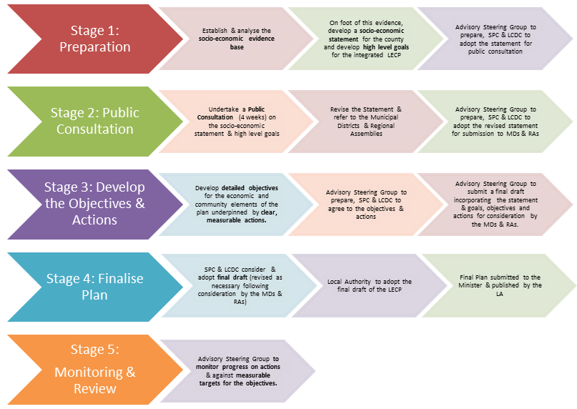
The LECP will identify specific community, social and economic priorities for the county for the next six years. The expectation is that relevant agencies/organisations working in the county will allocate a proportion of their budgets to the identified priorities in a coordinated manner.

The Kilkenny LECP is being developed as follows:

Phase 1: Developing the Socio-Economic Framework for the Plan
This involves identifying the context for the plan and includes:
• Analysis of socio-economic trends
• Review of relevant local, regional and national plans and strategies
• Identification of key issues, opportunities and high level priorities by key stakeholders/agencies
• Public Consultation on high level priorities and opportunities – Draft Framework Document.

Phase 2: Preparation of the Economic and Community Elements
This involves a more detailed consultation and analysis at a local level and includes:
• More in depth socio-economic analysis at area level
• Consultation with area-based and sectoral interest groups
• Preparing of draft economic plan
• Preparing draft community plan
We are at this point.
• Consultation on the draft plans

Phase 3 & 4: Further development and adoption of the Local Economic and Community Plan
These phases will include:
• Identification of specific actions & performance indicators
• Identifying the role and responsibilities of the various stakeholders/agencies in the delivery of objectives
              - Finalising the plan
              - Adoption of the plan
              - Publication of the Plan.

This will be followed by phase 5: monitoring and review of the implementation of the LECP.

  - Overview of Kilkenny LECP

INVITATION OF SUBMISSIONS
CONSULTATIONS WITH:
KEY STAKEHOLDERS

FOCUS GROUPS
MUNICIPAL DISTRICTS

2. DEMOGRAPHIC PROFILE OF KILKENNY: AT COUNTY LEVEL

2.1 Kilkenny Area Profile

County Kilkenny is a medium-sized inland county located in south Leinster, covering just under 2,100 square kilometres. County Kilkenny is part of the newly configured region of the South and is strategically located within the southern half of the country. The county is recognised as a very attractive place in which to live and work, and has a very successful tourism industry. The county has direct access to the Irish Sea via Belview Port on the River Suir and via New Ross on the River Barrow. Kilkenny City is the largest town in the county and dominates the local economy. This is followed by Ferrybank in south Kilkenny, which is growing rapidly and makes a significant social and economic contribution to Waterford city urban centre. Kilkenny city is in close proximity to Dublin (114 kilometres) and other major urban centres of Cork (146 kilometres), Limerick (110 kilometres) and Waterford (50 kilometres). Kilkenny is also close to Shannon International Airport (155 kilometres) and Rosslare Europort (105 kilometres).

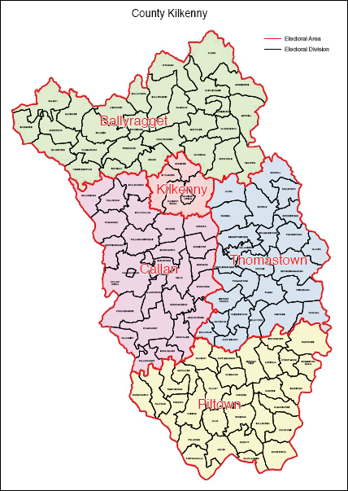
Figure1. Map of Kilkenny.

2.2 Population

Census 2011 records the population of County Kilkenny as 95,419 which is an increase of 7,861 over the population recorded in 2006. This is a 9% population increase for the county over the period and compares well with the State, which averaged an increase of 8%.
Kilkenny City (environs and borough area combined) recorded a population of 24,423 in 2011, which is an increase 2,244 (10.1%) over the population recorded in 2006.

Table 1: Recorded Population 1996 - 2011
 | 1996 | 2002 | 2006 | 2011
Kilkenny County | 75,336 | 80,399 | 87,558 | 95,419
Kilkenny City | 18,696 | 20,735 | 22,179 | 24,423

Population Trends
Census 2011 shows that the country continued to undergo strong population growth, with an 8.2% increase in the population of the State from 2006. The State has shown strong population growth since 1996 with increases in the region of 8% in each of the inter-censal periods. Kilkenny County has reflected this trend also with growth rates of 6.7%, 8.9% and 9% within the inter-censal periods.

Migration into the state has fallen from the high levels between 2002 and 2006 when it averaged 45,000 per annum to about 25,000 p.a. between 2006 and 2011. While this is a large fall in the number of immigrants, the increase in immigrants over the period is still significant given the economic downturn since 2007. Kilkenny has reflected this trend also with net migration of 3,895 (49% of total population increase) into the county between 2006 and 2011. The corresponding figure for 2002 to 2006 was 4,986 (69% of total population increase).

Population Change: Urban Areas
The major focus for expansion in population has been in the Environs of Kilkenny City and the Ferrybank area (Environs of Waterford City within County Kilkenny). An increase of 2,244 persons was recorded in the Environs of Kilkenny City in the period 2006 to 2011 while the Ferrybank area (Waterford City Environs within County Kilkenny) recorded an increase of 1,322 persons over the same period. Those two areas combined accounted for 44% of the total population increase within the county.

It is also significant to note that the Ferrybank area has consolidated itself as the second largest urban area within the county after Kilkenny City. Its population has increased by 123% since 2002.

Table 2: Population of the main Kilkenny towns and Ferrybank area
 | 2002 | 2006 | 2011
Callan | 1,325 | 1,771 | 2,330
Castlecomer | 1,482 | 1,531 | 1,456
Graiguenamanagh | 1,166 | 1,097 | 1,252
Thomastown | 1,600 | 1,837 | 2,273
Ferrybank Area | 2,142 | 3,465 | 4,787

This shows that Callan and Thomastown have performed well in terms of population increase since 2002, while Castlecomer and Graiguenamanagh have mixed performances showing both increases and decreases respectively in both census periods. The population of the county within aggregate town areas as defined by the census has increased from 35.3% in 2006 to 37% in 2011. This shows that the proportion of the population living in urban areas is increasing.

Population Change: Rural Areas
Figure 2 on the next page shows the population change across all rural Electoral Divisions (EDs) in the county between 2006 and 2011. There are 113 Electoral Divisions in the county and of these 12 experienced a decrease in population. The most significant of these was Castlecomer ED which experienced an actual decrease of 114 persons. (There were 31 Clar identified in County Kilkenny in 2011).

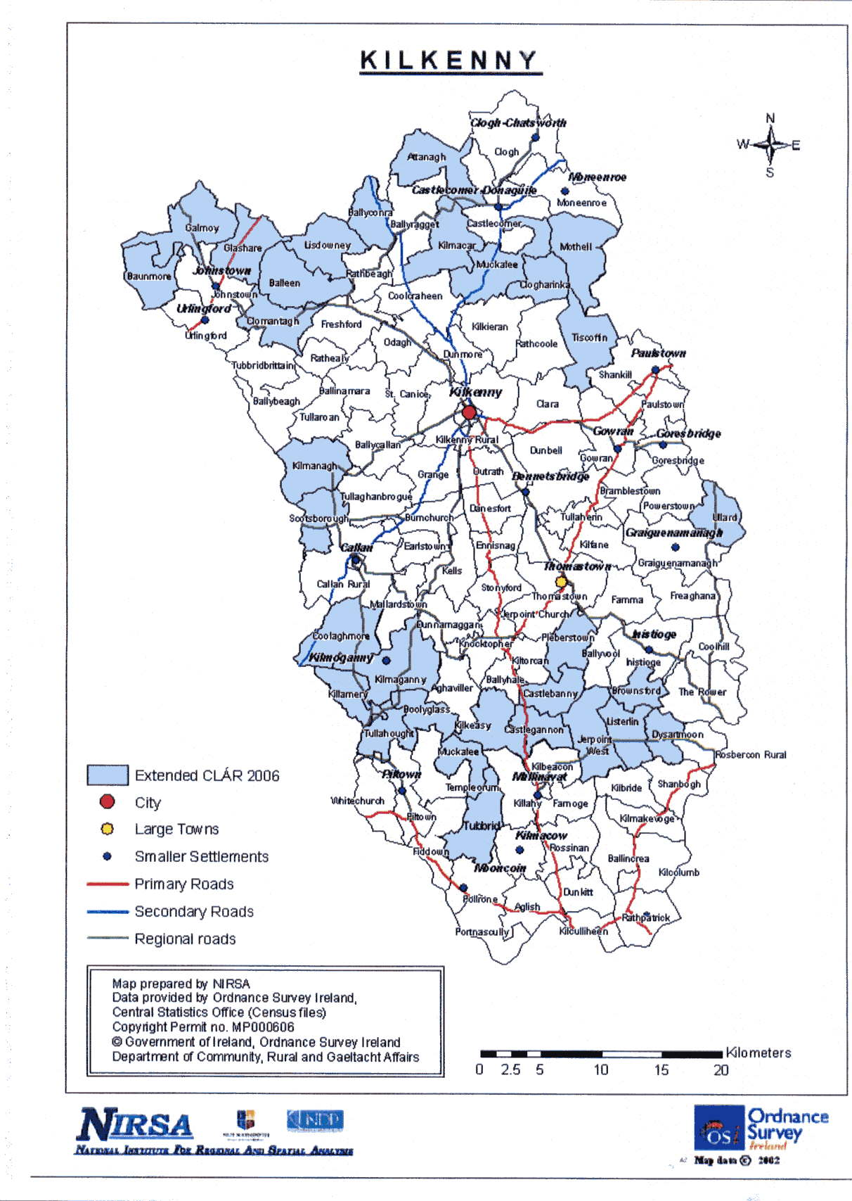

The report ‘This is Ireland – Highlights from Census 2011, Part 1’ (CSO, 2011) showed that the Irish Urban population has increased by 10.6 per cent while the rural population only grew by 4.6 percent. Kilkenny city has seen a percentage growth increase of 0.6% from 2006 to 2011. While this is well below the national average, the environs around Kilkenny city had a different rate of growth. In each of the rural towns in Kilkenny there have been differing rates of growth and decline as seen in the table below.

Population Forecasts
The 2011 Census recorded an actual population figure of 95,419 for the County. Accordingly Table 3 below gives a population target using the Regional Planning Guidelines (RPG) figures that have been adjusted to take account of the 2011 Census results.

Table 3: Adjusted Regional Planning Guidelines figures
 | 2011 Actual | 2012 | 2014 | 2016 | 2020 | 2022
Kilkenny County | 95,419 | 96,873 | 99,781 | 105,598 | 109,802 | 111,903
Kilkenny City | 24,423 | 24,723 | 25,323 | 25,800 | 27,400 | 28,200
Ferrybank/Belview | 4,787 | 4,953 | 5,287 | 5,412 | 6,412 | 6,500

2.3 Age Profile of the County

Age profile Kilkenny Population
AGE | MALE | FEMALE | TOTAL
<1-3 | 3,163 | 2,896 | 6,059
4-12 | 6,353 | 6,051 | 12,404
13-19 | 4,519 | 4,298 | 8,817
20-24 | 2,594 | 2,588 | 5,182
25-29 | 3,049 | 3,350 | 6,399
30-34 | 3,779 | 3,789 | 7,568
35-39 | 3,850 | 3,778 | 7,628
40-44 | 3,445 | 3,435 | 6,880
45-49 | 3,278 | 3,289 | 6,567
50-54 | 3,128 | 3,010 | 6,138
55-59 | 2,736 | 2,629 | 5,365
60-64 | 2,472 | 2,250 | 4,722
65-69 | 1,927 | 1,918 | 3,845
70-74 | 1,352 | 1,396 | 2,748
75-79 | 1,031 | 1,198 | 2,229
80-84 | 657 | 861 | 1,518
85+ | 455 | 895 | 1,350
Total | 47,788 | 47,631 | 95,419

These figures shave been round off to the nearest percentage and have different age
groupings than the table above.

Age Dependency ratio
‘As a proportion of the population, over 65s are growing faster than any other group and are expected to double in numbers by 2040’ (Action Plan for Jobs, 2014:130). (Haase and Pratschke, 2012) determine that counting those who are dependent as an indicator of Labour Market Situation is important where demographic growth is a measurement. In Kilkenny the rate of Dependency has increased by 4.6% and in Ireland as a whole it has increased to 5.1%. The age dependency rate allows us to make provision for the future of the country’s population in relation to areas such as healthcare, housing and welfare. There also has been an increase in births since the onset of the downturn and similar to the rest of Europe Ireland has a rising population of people over 65. This means that Kilkenny, similar to many other counties will have to plan for a future ageing population.

Local Authority Area | Age Dep  Rate  1991 % | Age Dep  Rate  1996 % |  | Age Dep  Rate  2002 % |  | Age Dep  Rate  2006 % | Age Dep  Rate  2011 % | % Change  2006‐2011
Kilkenny | 39.9 |  | 37.0 |  | 34.2 | 32.9 | 34.5 | 4.6
* Table 4: Percentage of population aged under 15 or over 64 years i.e. Age Dependency Rate *(www.pobal.ie)

‘Ireland has many of the essential building blocks for the development of a smart ageing sector in Ireland. Ireland has a National Positive Ageing Strategy as the blueprint for age related policy and service delivery, significant research and active NGO networks’ (Action Plan for Jobs, 2014). Kilkenny should be cognisant of these policies and networks when planning for the future.

2.4 Deprivation

Kilkenny, as a county, enjoys a status of relative affluence. In order to understand the deprivation issues experienced by particular groups and particular geographic areas it is important to highlight affluence versus deprivation. The concept of relative deprivation takes account of access to resources other than income. A deprivation index of items and activities that are generally taken to be the norm in a particular society is compiled, people who are denied, through lack of income, items or activities on this list are regarded as experiencing relative deprivation.

The term ‘consistent poverty’ describes someone whose income is below the relative/at risk of poverty threshold and who cannot afford at least two of the eleven deprivation indicators. The relative or at risk of poverty threshold represents an income of less than 60% of the national median (middle) annual income. In 2013 the national median income was €17,374 making the risk of poverty threshold €10,425 (a decrease of over 16% since 2008).

Table 5: Consistent Poverty Deprivation Indicators
- Two pairs of shoes | - Keep the home adequately warm
- A warm waterproof overcoat | - Buy presents for family or friends at least once a year
- Buy new not second hand clothes | - Replace any worn out furniture
- Eat meals with meat, chicken, fish (or vegetarian equivalent) every second day | - Have family or friends for a drink or meal once a month
- Have a roast joint or its equivalent once a week | - Have a morning, afternoon or evening out in the last fortnight, for entertainment
- Had to go without heating during the last year through lack of money

The Absolute HP Index Scores show the level of overall affluence and deprivation in 2006 and 2011, using identical measurement scales.

In simple terms, the Pobal HP Deprivation Index (Haase and Pratschke, 2012), is a method of measuring the relative affluence or disadvantage of a particular geographical area using data compiled from various censuses. A scoring is given to the area based on a national average of zero and ranging from approximately -35 (being the most disadvantaged) to +35 (being the most affluent). In addition to this, percentage data for the area is given under the following categories:
- Population Change
- Age Dependency Ratio
- Lone Parent Ratio
- Primary Education Only
- Third Level Education
- Unemployment Rate (male and female)
- Proportion living in Local Authority Rented Housing
Local Authority Area | Absolute  HP Index Score  2006 | Absolute  HP Index Score  2011 | Change in  Absolute  HP Index Score  2006‐2011 | Relative  HP Index Score  2006 | Relative  Index Score  2011 | Change in  Relative  HP Index Score  2006‐2011
Kilkenny | ‐.48 | ‐7.99 | ‐7.50 | ‐.48 | ‐1.01 | ‐.52
Table 6: Absolute and Relative HP Index Scores * www.pobal.ie
The relative index scoring focuses particularly on the previous two censuses, enabling easy comparison of data between 2006 and 2011. This index is of particular significance given the economic changes that have occurred nationally during this period.

Pobal Maps provide a visual representation of the data which is crucial in terms of highlighting pockets of relative disadvantage, especially to small area level, and is a valuable resource in targeting and tackling disadvantage. This level of detail can be viewed in Appendix I.

The following table highlights the electoral areas within county Kilkenny which have the highest deprivation ratings taken from the Pobal HP Deprivation Index 2011.

Table 7: Deprivation in order of need in county Kilkenny (2011)
1 | Urlingford | -12.1%
2 | Ferrybank | -11.2%
3 | Freshford | -9.6%
4 | Graiguenamanagh | -9.4%
5 | Clogh | -9%
6 | Castlecomer | -7.69%
7 | Callan Urban | -7.16%
8 | Kilkenny Urban 1 | -4.73
9 | Kilkenny Urban 2 | -0.9%

The Kilkenny Municipal Districts report (Appendix I) an accompanying document to this County Community Profile, small areas of poverty and deprivation have been clearly identified and relate to the electoral areas highlighted in Table 7 above.

Deprivation, poverty and social exclusion: Poverty has a negative effect on people's quality of life, on the opportunities open to them, and on their ability to participate fully in society. It can be difficult to break out of the cycle of poverty, as poor children are more likely to become poor adults. Poverty impacts on every aspect of a person's life:
Money and debt: many people who work in low-paid or insecure employment earn a wage that is not adequate to cover the basic costs of living for themselves and their families. Others are dependent on social welfare payments, whether because they are elderly, unemployed, carers, a lone parent, or have a disability or long-term illness.
Education: growing up in poverty can affect people's future: children who grow up in poor families are more likely to leave school early and without qualifications, and to end up unemployed or in low-paid jobs - which means that they are more likely to be poor as adults.
Health & well-being: people who live in poverty are at greater risk of poor mental and physical health: they get sick more often and die younger than people who are better-off. Factors such as an inadequate diet, a higher rate of chronic illness, a lower level of participation in sport and leisure activities, and a generally lower quality of life all contribute to lower levels of health and well-being among people who experience poverty.
Housing: people in poverty are more likely to be dependent on the State to meet their housing needs, whether through subsidised private-rented accommodation or social housing. They are also at greater risk of living in sub-standard accommodation and of becoming homeless.
Children and Families living in disadvantaged areas are not individually statistically represented in CSO, AIRO or other national profiles. Overall targeted work in Kilkenny has been prioritised by taking account of the Pobal HP Deprivation Index. It is expected that a County Profile will be developed by the Children and Young People Services Committee in the near future and will contribute to the implementation of this plan.

2.5 Unemployment

National Unemployment Rates
The unemployment rate for men in Ireland was an average of 5% from 2006 - 2008 but in 2009 it increased dramatically to 15.3%, followed by further rises over the next three years to reach 18.1% by 2012. There was a drop in the male unemployment rate in 2013 to 15.9% and another decrease in 2014 to 13.8%. The female unemployment rate, which averaged 4% 2006 - 2008, also increased strongly to 8.3% in 2009 and continued to rise over the next four years to reach 11.4% in 2013. However the female rate of unemployment decreased in 2014 to 9.9%. The younger age groups have been most affected by unemployment, with approximately three out of ten men and two out of ten women aged 20-24 unemployed in 2013.

(CSO Press Release Women and Men in Ireland 2013 http://www.cso.ie/en/newsandevents/pressreleases)
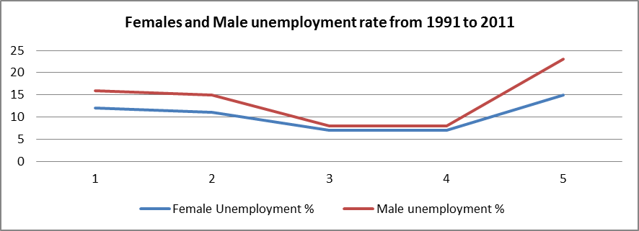
1991 1996 2002 2006 2011
Figure 3: CSO press release 2013.
Kilkenny Unemployment Rates (Male and Female)
Male unemployment in Kilkenny experienced a threefold increase, reaching 23.2% in 2011. This compared to a national male unemployment rate in 2011 of 22.3% and a two-and-a-half fold increase since 2006. Female unemployment in Kilkenny experienced a twofold increase, reaching 14.7% in 2011, compared to 15.0% nationally. (www.pobal.ie). The unemployment rate of males in Kilkenny can be seen as following the trends of the downturn in Ireland’s construction economy in 2008.

Local Authority  Area | Male  Unemployed  1991 -% | Male  Unemployed  1996- % | Male  Unemployed  2002- % | Male  Unemployed  2006 -% | Male  Unemployed  2011-% | % Change  Male  2006‐2011
Kilkenny | 16.3 | 14.5 | 8.2 | 8.0 | 23.2 | 190.7
Table 8: Male Unemployment Rate (www.Pobal.ie)

When looking at the female unemployment rate the patterns appear to follow Ireland’s economic boom and recession. However, the % of unemployed females remains at a much lower baseline rate with 14.75 being the highest rate of female unemployment in Kilkenny. This again points to the dominance of men in the construction industry and why their % of unemployment grew exponentially during the last decade.

Local Authority  Area | Female  Unemployed  1991 % | Female  Unemployed  1996 % | Female  Unemployed  2002 % | Female  Unemployed  2006 % | Female  Unemployed  2011 % | % Change  Female  2006‐2011
Kilkenny | 12.2 | 10.9 | 6.8 | 6.8 | 14.7 | 114.5
Table 9: Female Unemployment Rate (www.Pobal.ie)

The Live Register
The Live register is compiled from returns made directly to the CSO by each of the local offices of the Department of Social Protection. It is not designed specifically to measure unemployment. However, it provides an invaluable short-term and up-to-date indicator of unemployment and under-employed.
Included on the Live Register are the following:
- All those on Jobseekers Benefit (JB) – excluding systematic short time workers
- All those on Jobseekers Allowance (JA) – excluding smallholders / farm assists and self-employed persons
- Part-time workers (those who work up to 3 days per week) seasonal and casual workers entitled to Jobseekers Allowance or Benefit
- Those signing on for ‘PRSI credits’ but receiving no payment

In August 2010, there were approximately 5,216 men and 2,702 women on the County Kilkenny live register giving a total of 7,918 people. As of November 2014 there was a total of 6,064 people on the live register.
Table 10: Live Register Figures November 2014
Kilkenny City Social Welfare Office | 4,888
Thomastown Social Welfare Office | 1,176
Total | 6,064

Young People under 25 unemployed living in disadvantaged areas
Kilkenny County (under 25 unemployed) as of Jan 2012 - Airo | Total | Total all live registers KK | Under 25 as a % of total unemployed
KK City – under 25 unemployed  Urban 1  Urban 2  Rural KK | 256  163  93  287 | 1,685  1007  678  2533 | 15.2 %  16.2%  14%  11%
Callan  Urban  Rural | 69  44  25 | 465  298  167 | 14.8%  15%  14.9%
Thomastown | 41 | 363 | 11.3%
Ferrybank environs: i.e. Kilculiheen DED | 84 | 814 | 10.3%
Urlingford | 34 | 191 | 17.8%
Castlecomer/Donaguile | 60 | 368 | 16.3%
Clogh | 33 | 193 | 17%
Moneenroe | 34 | 195 | 17.4%
Ballyragget | 27 | 191 | 14.1%
Piltown | 41 | 291 | 14.0%
Graiguenamanagh | 30 | 275 | 10.9%
Table 11: created by CKLP using Pobal HP Deprivation Index and Pobal Maps with overall data.

Labour Force
Commerce and Trade has continued to be a large employer throughout County Kilkenny. There are approximately 37,273 workers enumerated in Kilkenny of which 9,054 worked outside the area. The daytime working population (resident and non-resident) of Kilkenny was 27,485 (CSO, 2011).

Social Class
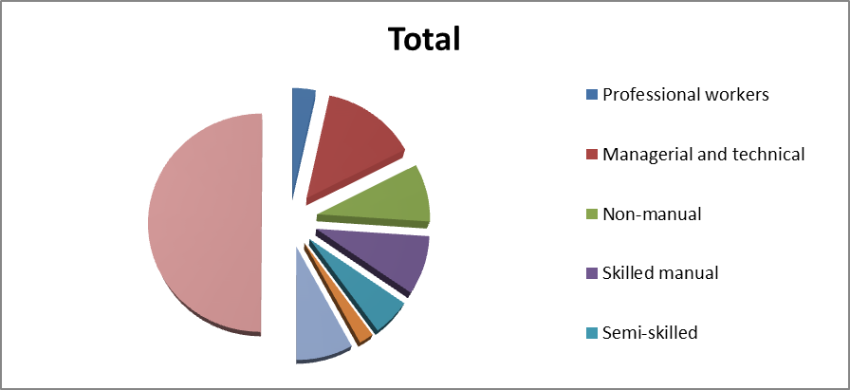
In Kilkenny, the proportion of workers in the professional classes (34.9%) and the proportion in the lower skilled professions (17.6%) mark a class composition almost identical to the national average. Unskilled workers and semi-skilled workers typically have skills that are associated with the building and construction sector and these categories are the lowest percentage that is gainfully employed within County Kilkenny.

2.6 Education

Primary Education Only
In Kilkenny County there have been decreases in the numbers of students who are leaving school with just a primary level education. This decrease has been due to a number of factors some of which are driven at a national policy level, e.g. where the age for leaving school increased to 16 and other local initiatives in Kilkenny, i.e. focused through programmes such as the School Liaison, Youth reach, NALA, and the ETB’s.

Local Authority Area | Low Education  1991 % | Low Education  1996 % | Low Education  2002 % | Low Education  2006 % | Low Education  2011 % | % Change  2006‐2011
Kilkenny | 35.7 | 28.7 | 22.0 | 18.4 | 15.1 | -17.9
National 15 years and over |  |  |  |  | 12.66
Table 12: Proportion of Population with Primary Education only * (www.pobal.ie)
There have been determined efforts made in retaining pupils up to and past secondary education. However, despite the improvement at county level, there remain several rural EDs where considerable parts of the adult population have primary education only. Examples include Freshford (26.8%), Goresbridge (25.6%), and Graiguenamanagh (25.2%).

In addition minority groups such as Travellers continue to struggle with retention throughout primary education. In Kilkenny city, the Kilkenny Traveller Community Movement (KTCM) have identified that areas such as St. Mary’s and St. Catherine’s halting sites need extra school support. “Education was identified as the main area of concern for Travellers living throughout Kilkenny. Concerns ranged from; there being no pre-school in Rosbercon and a poor relationship with secondary school teachers, to many Travellers still leaving school without being able to read and write, and there not being enough support for homework at school.” (KTCM, 2013:25)

At a social class level Kilkenny county reflects the educational attainment profile of each area with Bramblestown having the highest composition (56.0% professionals, 8.0% semi- and unskilled manual classes), and Callan Urban (22.0% professionals, 26.1% manual classes) and Urlingford (17.7% professionals, 24.5% manual classes) having the lowest.

2.7 Lone Parents

According to National Economic and Social Forum (2001:17) and the Combat Poverty Agency (2010) ‘lone parents’ are defined as those, who are parents who have characteristics such as; being most likely to be women, sole carers of their children and recognised by their marital status such as separated, widowed, divorced or never married. There were 215,300 families headed by lone parents with children, 87 per cent of which were lone mothers. Two fifths of lone parents were single and just under a quarter were widowed. 31.8 per cent were separated or divorced, compared with 29.8 per cent in 2006

The Central Statistics Office Social Inclusion report 2013 (Chap 3: p52) states that there is a 28% chance that a household that has one parent and a child aged under 18 are most likely to fall into the category of people living in poverty. This is almost twice the rate of a two parent family likely to live in poverty estimated at 14.6%. Adults and children in one-parent families have the highest deprivation rate in Ireland (56%) a very significant increase since 2009 (44%).

Local Authority Area | Lone Parent  Rate  1991 % | Lone Parent  Rate  1996 % | Lone Parent  Rate  2002 % | Lone Parent  Rate  2006 % | Lone Parent  Rate  2011 % | % Change 2006‐2011
Kilkenny | 8.3 | 10.4 | 13.0 | 16.9 | 17.8 | 5.5
Table 13: Lone Parent Rate * (www.pobal.ie) Percentage of single parent households with at least one dependent child (aged under 15) as a proportion of all Households with at least one dependent child (aged under 15).

There are 3,782 lone parent households in Kilkenny; 84% lone mothers, 16% lone fathers. One-parent families make up 11% of all households in Kilkenny. The steady rise in Lone Parents is a cause for concern in the profile of county Kilkenny and requires prioritisation and further research as part of the LECP implementation phase. The number of Lone parents by Municipal District and Small Area Population is given in Appendix III – a supplementary report to this County profile.

2.8 Housing

There has been a 1.9 percentage point decrease in the proportion of local authority housing in Ireland over the past 20 years, from 9.8% in 1991 to 7.9% in 2011. The proportion in the South East Region has declined by 1.1 percentage points, from 10.2% to 9.1%. Similarly, County Kilkenny has seen a marginal decline in the proportion of local authority housing, albeit from a lower base (7.7% to 7.1%). The highest concentrations of local authority housing are found in Kilkenny No. 1 Urban (17.1%) and Kilamery (14.1%), but these are still low levels compared to those found in most larger towns and cities. Kilkenny County has a large number of schemes administered by the Local Authority - Kilkenny County Council. ‘Kilkenny County Council is responsible for the management of just under 2,200 tenancies which are located in both the city and the county’ (Kilkenny LA Estate Management Plan 2015-2020). The schemes include; Council Houses, Long Term Leasing, Rental Accommodation Scheme (RAS), Loans & Grants and a new pilot Housing Assistance Payment (HAP). These schemes allow those who may be otherwise unable to live in their own homes to afford to live in Kilkenny county. Like all counties in Ireland Kilkenny County Council caps its schemes and this is based on a means assessment of a person’s reckonable income. Table 13 below shows that local authority housing rental rates have remained between 6 and 8 % since 1991.

Local Authority Area | LA Rented  1991 % | LA Rented  1996 % | LA Rented  2002 % | LA Rented  2006 % | LA Rented  2011 % | % Change 2006‐2011
Kilkenny | 7.7 | 7.0 | 6.5 | 6.0 | 7.1 | 18.5
National |  |  |  |  | 29
Table 14: Local Authority Housing * (www.pobal.ie)
* Note: This indicator is not included in the construction of the Pobal HP Deprivation Index.

Local Authority Area | Privately  Rented  1991 % | Privately  Rented  1996 % | Privately  Rented  2002 % | Privately  Rented  2006 % | Privately  Rented  2011 % | % Change in  Privately  Rented  2006‐2011
Kilkenny | 5.0 | 6.7 | 8.1 | 10.3 | 14.8 | 43.9
Table 15: Privately Rented Housing * (www.pobal.ie)

When comparing the table of those who rent private accommodation and those who rent Local Authority homes there is a large disparity. It seems that there has been a substantial increase in people renting which could coincide with the downturn in the economy and the collapse of the financial sector in Ireland. Lending for mortgages have been very low since 2008 and this can be another reason for the large increase in private rental accommodation in Kilkenny and Ireland.

2.9 Homelessness

Changes and Issues arising over the last year
- Increase in economic homeless presenters due to increased rents and unavailability of affordable private rented accommodation.

- Inability to provide exit strategy from homeless services to private rented sector due to high market rent, unavailability of Private Rented Accommodation, landlords refusing to accept social housing support tenants.

- Increased pressure on emergency homeless providers due to increase in presentations, lack of exit strategy, working at capacity.

- Increased pressure on Kilkenny County Council to provide emergency B&B when emergency homeless providers are at capacity and presenter has no alternative housing options available.

- Increased pressure on Kilkenny County Council to meet on going demands of service users in emergency accommodation settings and awaiting appropriate referral.

- Inability to provide emergency homeless accommodation in alternative locations (other counties) due to pressures and capacity issues on the particular County Council and our inability to provide exit strategy within the short term.

- Dealing with complex cases and finding appropriate referral pathways (if any) whilst dealing with the above.

Comparative figures showing increase in homeless / potential homeless presentations to housing services:
Between 01/10/ 2013 – 04/02/2014 there were 45 homeless/potentially homeless presentations with this figure almost tripling to 133 for the period 01/10/2014 – 04/02/2015.
In the period 01/01/2014 – 01/05/2014 there were 78 homeless/potentially homeless presentations while this figure more than doubled to 167 for the period 01/01/2015 – 01/05/2015.

In 2014 ‘Amber’ Kilkenny Women's Refuge accommodated 9 women and 4 children as a direct result of homelessness. Amber accommodated a further 16 women and 14 children who were admitted under Domestic Violence but ended up homeless due to such factors. As a service, Amber found it very hard to source adequate, private rented or Local Authority accommodation in Kilkenny for families experiencing homelessness. Families struggled to source a new home for themselves which added massive strains to their already difficult situations.

“This in turn affected our service as clients are staying much longer than before. Our Policy states that we provide short term emergency accommodation for 8 - 10 weeks but this is not the case anymore due to the difficulties in sourcing accommodation for our clients. This also affected our referral system as we are turning away hundreds of referrals per year due to our refuge constantly being full” (Amber, 2015).
These concerns and pressure on housing was echoed by the Good Sheppard Hostel Service (Homeless Hostel) located in Kilkenny City:

- There is a crisis in the lack of supply of a priority accommodation, both in the Private Rented Sector, Social Housing Sector and Local Authority.

- Lack of appropriate responses to complex cases. Clients who have dual diagnosis (substance misuse & mental Health or clients who personality or behavioural disorders)

- Rates of social welfare for those under the age of 24 is a contributing factor to clients financial ability to enter into tenancies.

- Reluctance on behalf of some landlords to engage with Housing Support Services e.g. HAP, RAS

- Severe cuts in homeless budgets in the past few years (No cuts in 2014 and as of yet no cut 2015) but no increase in budget.

- Emergency services are at full capacity with few options for these clients to move on or exit strategies being available.

- Need for re-establishment of a County homeless structure.

2.10 Health & Well-being

Deprivation is frequently associated with poor health and health inequalities, i.e. unequal access and outcomes for those of lower socio-economic status. 85,069 persons stated they were in good or very good health representing 89.2% of total persons. This compares to 88.3% nationally. 1,324 persons stated they were in bad or very bad health, representing 1.4% of total persons in this area. Again this compares with 1.5% of total persons nationally.
A specific workshop was held to examine health and well-being priorities and the following were identified:
- Homelessness must be a priority for all services
- Greater supports and services for people with a disability
- Delivery of the Kilkenny action plan for suicide prevention
- Prioritisation of drug-prevention initiatives among young people
- Prioritisation of Travellers and ethnic minorities by all health services
- Increase whole population approaches to health improvement

2.11 People with a Disability

There was a total of 595,335 people with a disability in April 2011 accounting for 13.0 percent of the population, up from 393,785 in 2006 when it accounted for 9.3 per cent of the population. The largest increases in percentage terms were seen in children aged under 5 where the numbers increased by 90 percent from 5,298 to 10,084. The widespread incidence of childhood asthma and the specific reference to ‘breathing’ difficulties in the ‘other’ category may partly explain this. The rates of disability increased within this age group, the exception being people in their twenties, who had lower disability rates than teenagers. While overall the rates for men and women were similar, at 12.7 percent and 13.2 percent respectively, there were variations by age group with male excesses in the 0-29 age groups and female excesses from age 70 onwards (CSO-This is Ireland Highlight 2011, pg 43).

According to the 2011 Census, Kilkenny had 11,939 persons (13%) with a disability, of whom 4,309, (36.1%) of the total, were aged 65 years and over. 4,055 persons (1,536 males and 2,519 females) provided regular unpaid personal help for a friend or family member with a long-term illness, health problem or disability. 21.7% of these provided care for more than 6 hours per day (www.cso.ie).

Age | Nos | % | - 33% of people with a disability of working age are employed compared to 63% of those without a disability.  - 18% of people with a disability did not progress past primary education compared to 3% of those without a disability.  - 22% of people with a disability left school at lower secondary level compared to 16% of those without a disability.
0 – 14 | 1,103 | 9.2
15 - 24 | 832 | 6.9
25 - 44 | 2,209 | 18.5
45 - 64 | 3,486 | 29.1
65 + | 4,309 | 36.1
Total | 11,939 | 100
Table 16: DFI data for Kilkenny 2015

2.12 Ethnic Minorities & Travellers

Ethnic Minorities
County Kilkenny |  |  | Ireland
Country of Birth | Population | % of Immigrant Population | Country of Birth | Population | % of Immigrant Population
England and Wales | 4,689 | 39.3 | England and Wales | 212,286 | 27.7
Poland | 2,033 | 17.0 | Poland | 115,193 | 15.0
Northern Ireland | 462 | 3.9 | Northern Ireland | 58,470 | 7.6
Lithuania | 396 | 3.3 | Lithuania | 34,847 | 4.5
United States | 375 | 3.1 | United States | 27,726 | 3.6
Latvia | 275 | 2.3 | Latvia | 19,989 | 2.6
Romania | 238 | 2.0 | Nigeria | 19,780 | 2.6
Nigeria | 162 | 1.4 | Romania | 17,995 | 2.3
Scotland | 197 | 1.7 | Scotland | 17,871 | 2.3
India | 181 | 1.5 | India | 17,856 | 2.3
Table 17: CSO Census 2011
Table 18: Size of Ethnic Minority Population in Kilkenny 2011
Nationality | Birthplace |  | Ethnicity
Non-Irish nationals | Born outside Ireland | Born outside Ireland & UK | Ethnic groups with roots in other countries | Ethnic Traveller Community
8.9% | 12.6% | 6.9% | 9.4% | 0.5%
8,367 | 11,929 | 6,581 | 8,829 | 483
These statistics can be summarized as follows:
- 8.9% were non-Irish nationals
- 12.6% were foreign-born (6.9% were born outside UK and Ireland)
- 9.4% belong to ethnic groups with roots in other countries;
- while a further 0.5% belong to the Irish Traveller Community

Travellers

A study carried out by the Kilkenny Traveller Community Movement (KTCM) highlight key data and concerns of the Traveller community in Kilkenny:

Table 19: Traveller Population around County Kilkenny (according to census)
Electoral Areas | Census 2006 | Census 2011
Kilkenny City (urban areas & rural environs) | 156 | 263
Piltown | 111 | 84
Ballyraggett | 31 | 40
Thomastown | 45 | 86
Callan (urban areas & rural environs) | 18 | 10
Totals | 361 | 483

- There are 483 members of the Traveller Community in County Kilkenny (i.e. 0.5% 0f the population of Kilkenny) according to Census 2011
- However, there are 177 families according to the Traveller Count for Kilkenny 2012, which suggests a slightly higher number than the census figures suggest.
- The Traveller community’s share in Kilkenny City’s population, at 1.1% is almost twice as much as their share in the county’s overall population.

Table 20: Traveller Unemployment (adults over 18) | 234 | 100%
Unemployed or on  Job Seekers allowance, Lone Parents allowance | 207 | 88.5%
Working e.g. community worker or on a scheme, e.g. FÁS | 18 | 7.5%
Retired | 3 | 1.5%
Disabled | 6 | 2.5%
Traveller Unemployment

- LIST OF RELEVANT PLANS, STRATEGIES & SERVICES REVIEWED

  - Plans and Strategies
The following reports and strategies were reviewed and informed the development of this draft community plan (see Appendix II for a summary of the review):
- Ireland’s National Traveller / Roma Integration Strategy 2011 – 2016
- Better Outcomes Brighter Futures: The national policy framework for children & young people 2014 - 2020
- The South East Homelessness Action Plan 2013 – 2016
- National Social Housing Strategy 2020)
- National Disability Strategy Implementation Plan 2013-2015
- National Action Plan for Social Inclusion 2007-2016
- Rural Social Inclusion: Rural Poverty and Social Exclusion on the Island of Ireland – Context, Policies and Challenges by Dr. Kathy Walsh, KW Research and Associates Ltd. 2010
- Building Strong and Inclusive Communities: A regional strategy for LGBT Inclusion and Support in the South East 2013-2018
- OECD Delivering Local Development: Ireland 2013
- Guidance on Community-led Local Development in European Structural and Investment Funds Version 2: May 2014
- Healthy Ireland – A framework for Improved Health and Wellbeing 2013 – 2018
- A Draft Framework Policy for Local and Community Development in Ireland March 2015
- Kilkenny Age Friendly Strategy 2011-2015
- Uniting the Diverse- Kilkenny Integration Strategy 2013-2017
- Kilkenny Traveller Interagency Group reports
- Kilkenny Traveller Community Movement (KTCM) 2020 Strategy
- South East Traveller Health Unit Strategic Plan 2015-2020
- Ferrybank Community Development Strategy 2015-2020
- Kilkenny Recreation & Sports Partnership
- Kilkenny County Council Estate Management Strategic Plan 2015-2020
- Kilkenny Social Housing Strategy
- Strategic Framework for Family Support within the Family and Community Services Resource Centre Programme. Family Support Agency Revised Edition January 2013.
- One Parent National Strategy
- South East Regional Drug and Alcohol Task Force DRAFT 2015 Priorities
- Our Community, Our Conversation: Co Kilkenny Action Plan for Suicide Prevention 2014 – 2018 Lifeline Kilkenny

  - Mainstream & Voluntary Services
The following services were identified and considered in the development of this draft community plan (details are given in Appendix II).
- Kilkenny County Council – various local services.
- Department of Social Protection, related welfare schemes and Intreo.
- Solas Employment & Training Services Kilkenny.
- County Kilkenny LEADER Partnership – Local Development Company operating the Social Inclusion Activation Programme and the Rural Development Programme.
- Tusla – Child & Family Agency.
- Carlow/Killkenny HSE services; addiction, child and adolescent psychiatry, St. Lukes, Local Health Office, Health Promotion and Disability Services – who work with and fund local organisations.
- There are sixteen Post Primary schools in Kilkenny and up to eighty primary schools.
- Carlow Kilkenny Educational and Training Board.
- Kildalton College, the largest agricultural college in the county is located in Piltown, County Kilkenny.
- Main Youth service providers; Ossory Youth, Foroige, Macra Na Feirme: Scouting Ireland. Family Resource Centres (FRC) in Kilkenny City.
- Kilkenny County Childcare Committee supports the development of a quality early childhood care and education sector throughout Kilkenny City and County.
- Kilkenny Citizens Information Centre gives a free and confidential information service on all aspects of the social services including housing, health, social welfare, law, employment, pensions, and tax and consumers affairs. It has three outreach offices: Kilkenny City, Graiguenamanagh and Mooncoin.
- MABS outreach office at William Street, Kilkenny. This is the only MABS office in the county.
- Family Resource Centres: There are four Family Resource Centres (FRCs) operating in Kilkenny: St. Canice’s Community Action FRC services a section of western Kilkenny City. Droichead FRC’s service the Callan area. Newpark Close FRC services a segment of the eastern part of the city based around that titular housing estate. The Mill FRC is located in Urlingford.
- Travellers: Kilkenny has an interagency group and aproach to working with the Traveller community. Kilkenny County Council is the lead agency with responsibility for accommodation for Travellers. Kilkenny LEADER Partnership supports the following projects with the local Traveller community; The Traveller community health project which was established by the HSE following the All Ireland Traveller health study 2010. Kilkenny Traveller Community Movement (KTCM) is a Traveller led organisation which supports Travellers and Traveller community development throughout County Kilkenny. KTCM aims to provide a supportive environment for all Travellers in County Kilkenny to work together and make progress.
- Other Specialised services: The Good Sheppard Shelter provides short term accommodation for homeless men while the Amber Refuge Centre provides a similar service to woman. Immigrant Community Services (DOCHAS) and the Failte Isteach projects provide information and language supports to the immigrant community.
- Kilkenny Forum for Social Inclusion and Participation – A Federation of Community based organisations for combating inequalities and promoting social justice.

- Consultations

The development of the Local Economic and Community Plan (LECP) will be underpinned by significant public and stakeholder consultation to ensure the best possible LECP for Kilkenny is produced. On the community element, consultations will take place with the Local Community Development Committee (LCDC) in addition to open public consultations at municipal district level (4 scheduled for June - July 2015). Due to a lack of hard data being readily available or a strong evidence base in the form of reports, several themes were identified for focus group stakeholder consultation and these workshops were planned for May – June 2015. The following thematic focus group meetings were held to date: Health & Well-Being and Social Inclusion, Lone Parents, Youth & Unemployment.

Additional bi-lateral meetings are on-going in relation to key strategies already in place in the county, e.g. suicide prevention, Traveller strategy, disability, older people and x.

Verbal submissions and written submissions are now invited as part of this development phase and will remain open until the end of July 2015.

Following the consultation period the LECP team at Kilkenny County Council will arrange emerging themes and actions in a plan that is consistent with regional, national and European policy, i.e. the key objectives of the national reform programme, action for jobs and Europe 2020 vision. The aim is to have an LECP that has clear high level goals and actions which can be monitoring and measured in terms of social and economic impact. See template at the end of this document.

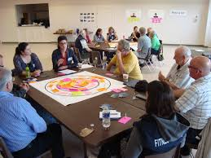
- HIGH LEVEL GOALS: THEMES AND PRIORITIES

PRIORITY AREA | HIGH LEVEL GOALS/OBJECTIVES | STRATEGIC ACTIONS
AREA-BASED POVERTY & DISADVANTAGE | - Improve the DEPRIVATION indicators for those Electoral District areas designated ‘disadvantaged’ or ‘very disadvantaged’.
 | - Improve the DEPRIVATION indicators for those small areas designated ‘disadvantaged’ or ‘very disadvantaged’.
 | - POVERTY: EDUCATION – Increase the level of educational attainment for those living in disadvantaged areas.
 | - POVERTY: UNEMPLOYMENT – Reduce the level of unemployment in disadvantaged areas.
 | - POVERTY: YOUTH UNEMPLOYMENT – Reduce the level of youth unemployment in disadvantaged areas.

POVERTY & SOCIAL EXCLUSION | - Ensure the inclusion and active engagement of all citizens in the social and economic development of County Kilkenny.
 | - In particular focus attention on Lone Parents, Travellers, Ethnic Minorities, Older people, People with a Disability and Children & Young People. Ensure such groupings are prioritised in relation to poverty goals.

COMMUNITY DEVELOPMENT | - Ensure all citizens of Kilkenny (rural and urban based) have access to appropriate community facilities.
 | - Ensure all facilities are utilised to their optimum capacity, open and available to all citizens.
 | - Ensure community development coordination at Municipal District level to support communities at local level
 | - Increase community participation and civic engagement at both Municipal District and at County Level.

HEALTH & WELL-BEING | - Ensure the health and well-being of all Kilkenny’s citizens is maximised.
 | - In particular focus attention on the following areas: People with a Disability, Substance Misuse, Mental Health & Suicide, Travellers, Ethnic Minorities, Homelessness and LGBTI.

Template for Community Plan 2016-2020 (Phase 3 & 4)
EU 2020 priority:

LECP High Level Goal:

Sustainable Community Objective

Inputs | Actions | Outputs | Outcomes | Impacts

APPENDIX I:

Please contact the Community & Culture section of Kilkenny County Council by phone on 056-7794920 or by email to community@kilkennycoco.ie for further information on the Municipal District profiles.

http://www.cso.ie/en/census/census2011reports/census2011thisisirelandpart1/
Figure for Kilkenny city is for the Borough Council area plus the environs of the City within the County area.
These figures do not include the Tinnahinch area in Graiguenamanagh, located within Co. Carlow.
Urban areas as defined by CSO i.e. towns with populations of 1,500 or more. If Tinnahinch is included within Graiguenamanagh, then the population of the town would be 1,543.
The 2014 figures are obtained by disaggregating the RPG figures and applying the same growth rates to the 2011 Census figure.
The population increase allocated to the Environs of Waterford is 1,000 people from 2010 to 2016, a rate of 166.6 per year. This figure is for the Kilculliheen & Aglish EDs only, it does not relate to the entire Ferrybank/ Belview Local Area Plan area.
http://www.combatpoverty.ie/povertyinireland/whatispoverty.htm
AIRO = All-Island Research Observatory.
https://www.pobal.ie/Publications/Documents/Pobal%20HP%20Deprivation%20Index_Inter_temporal%20Analysis%20of%20Small%20Area%20Deprivation%20Scores%202006%20%e2%80%93%202011.ppt
https://www.pobal.ie/Publications/Documents/Pobal%20HP%20Deprivation%20Index_Inter_temporal%20Analysis%20of%20Small%20Area%20Deprivation%20Scores%202006%20%e2%80%93%202011.ppt
www.pobal.ie
According to Census 2011, the total population of Kilkenny is 94,584. However, there may be a slight variation if the percentages stated in this table are applied to that total due to the fact that a small number of people did not state their birthplace or ethnicity on the census form; therefore actual numbers of those who did give this information are also given above in Table 18.
Strategic Actions will be identified and agreed in the consultation phase.
Facilities, Infrastructure, Area Co-ordination, Community Development Activities and Programmes and Participation.

