I’m a computer programmer. I just moved back to Kilkenny because, after about a year of searching, I managed to find a job in my field in Kilkenny. There aren’t many programming jobs in the south east of Ireland. But this may change. I think the brewery site could be a hub for IT companies in the future. But only if it is done properly.
IT companies and other high skilled companies will relocate in Kilkenny if they can get the staff they need (or convince them to move here). Kilkenny has many qualities that will attract such workers – it’s a beautiful place, has nice cafes and restaurants, and housing is cheaper than the bigger cities.
But it also has problems. There is a serious shortage in housing, especially good quality housing. House prices will rise. And it is way too car-centric. Young talented urban professionals like to walk and cycle to work. Many don’t have cars. This is a serious problem in Kilkenny.

Social housing
As already stated, we have a serious shortage in housing in Kilkenny. I am all in favour of building housing on the brewery site, but we really have to think about the kind of housing we build here.
Much of the housing that has been built in Kilkenny in the last few years isn’t the kind of housing people today really want. Sure, people will buy it, if it is all there is, but given a choice, I think people would like to live somewhere that is better designed. People want to walk to the shops, cycle to school with their children and get to know their neighbors. If housing is designed properly, it can help give people the quality of life they desire.
What is shown in the brewery plan is just the same boring, dull, car centric design that was built during the boom in Kilkenny. There has not been any real thought as to what could be build there. Shouldn’t we be aiming from inspirational homes that give a better quality of life, promote community and social interaction? Does every house need to be right beside the road? Where will people sit in the evenings to talk to their neighbors? How will they walk to the shops? Can the right housing help make people fitter? There is plenty of car parking, but where will people keep their bikes? Can the design encourage people to walk with their children to school rather than drive?
I think the council should be aiming to build great housing on the brewery site. Housing that could be nominated for an award. Housing that stands as an example to developers wanting to build in Kilkenny as to what is possible. This is a very important point! We need more housing – but it is very hard to build it if people object to it. And people object to ugly housing. If it is done properly, people don’t object. We need to think about what is best long term for Kilkenny. We need good quality urban housing if we want to attract the high skilled workers and companies to Kilkenny. Modern, urban, dense and beautiful housing in a walkable city. And this is a change to show developers what we want the future of housing in Kilkenny to be!
Have a look at Accordia, in Cambridge for inspiration - http://fcbstudios.com/work/view/accordia. This housing development won the Stirling Prize. Shouldn’t we aim for something similar? It doesn’t have to cost more, but we could build something so much better.
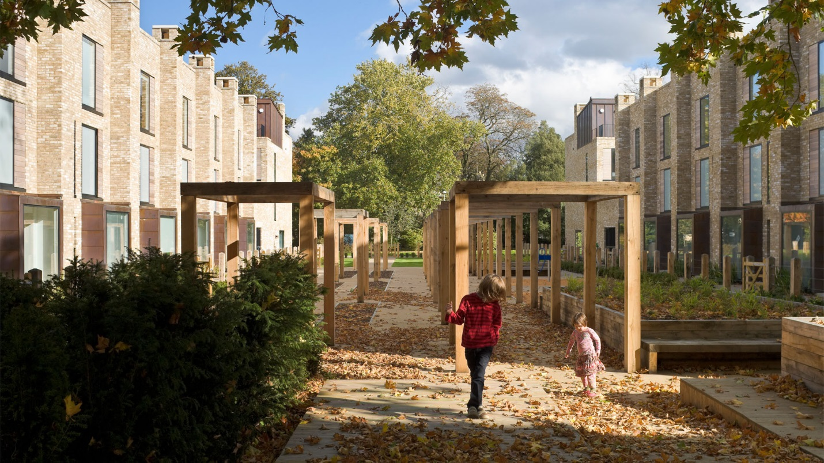
Also, another problem we have today is empty nesters not willing to move out of half empty houses. Many people want to stay living in the community they know. Has this been considered here? Is there enough variety in housing for the long term of the community that will live there?
I know we have a shortage of housing in Kilkenny, but that isn’t a good enough excuse to build the wrong thing.

Cycling Infrastructure
The World Health Organization recently released a report stating that Ireland is soon going to be facing an ‘obesity epidemic’. Every county in Europe is getting fatter, except The Netherlands. How can we tackle this? We’re also going to become a much older population over the next 40 years.
So what have these two thing got in common – Cycling infrastructure. I lived in the Netherlands for about six years. I’d like to note two things.
- Most foreigners that moved to the Netherlands didn’t cycle on arrival. But pretty soon, everyone gets a bike and uses it. Why? Because it is handy, quick and cheap to use. But also because the bike infrastructure is there, it is safe. A good cycling infrastructure will get people cycling.
- Many people with disabilities and older people use the cycle tracks with their mobility scooters. This gives them freedom and independence that such people wouldn’t have in Kilkenny – see this short video to get an idea (4 minutes) - https://www.youtube.com/watch?v=xSGx3HSjKDo Think about where to population of Kilkenny is going. We are going to have a lot more older people in the future, and helping them stay active will be very important.
If we can get more people cycling in daily life in Kilkenny this will
- help reduce obesity
- reduce traffic
- improve the quality of life – which will help attract high skilled workers/companies to Kilkenny
- and a better infrastructure will allow older/disabled people have more freedom in the future
But these aims are long term, and need a lot of work. The cycling infrastructure in Kilkenny is awful. Really awful. Sorry. But hopefully I’ve convinced you of why it needs to be better. And we can make it better. There are a few things that could be improved in the masterplan to help this.
- Secure bike parking in at least one building on the site.
- The main road way thought the site will be for both pedestrians and cyclists. But in the pictures, there is not cycle path shown. If you really want to increase cycling in Kilkenny, there needs to be a dedicated cycle track. Shared spaces don’t work. It causes conflict and slows down cyclists. If I’m in a rush to work, I don’t want to meander through tourists. You wouldn’t place pedestrians and cars in a shared space, so why do it with cyclists? http://www.makingspaceforcycling.org/#principles
- More thought has to be put into how cyclist and pedestrians will cross the roads into the site. Example: If I’m cycling over Green’s bridge into town, where do I go? The brewery site doesn’t exist on its own, but as part of a bigger picture. The linking into the site for pedestrians and cyclists needs to be looked at in more detail.

