2

Urban Design Framework / Masterplan for Abbey Creative Quarter

Section One: Introduction

1 Introduction
1.1. Introduction
1..2 Project Brief
1.3 Public Consultations
1.4 Appropriate Assessment
1.5 Strategic Environmental Assessment

Section Two: Context

2.1 Historical Context of Kilkenny
2.1.1 History of Kilkenny
2.1.2 Timeline for Kilkenny
2.1.3 Townscape and Urban Structure
2.1.4 The City and the River

2.2 Current Context of Kilkenny
2.2.1 Vision arising from Public Consultation
2.2.2 Kilkenny attracting New Industries

Section Three: Analysis

3.1 Masterplan Area Context
3.1.1 Description of Study Area
3.1.2 Context of the Study Area
3.1.3 Statutory Planning & Planning Policy
3.1.4 Site Analysis - Archaeology
3.1.5 Site Analysis - Views
3.1.6 Site Analysis - Architectural Heritage
3.1.7 Site Analysis - Conservation Policies
3.1.8 Site Analysis - Linear Park
3.1.9 Site Analysis - River Bank
3.1.10 Site Analysis – Tourism
3.1.11 Site Analysis – Flood Risk
3.1.12 Site Analysis - Urban Scale

3.2 Urban Planning & Analysis
3.2.1 Site Analysis – Lynchian Method
3.2.2 Opportunities and Weaknesses
3.2.3 Context

Section Four: Masterplan Strategies

4.1 Connectivity and Movement Strategy
4.1.1 Smarter Travel / Mobility Management Plan
4.1.2 Key Connectivity and Movement Issues
4.1.3 Pedestrian & Cyclist Movement
4.1.4 Vehicular Movement
4.1.5 Public Transport
4.1.6 Parking / Traffic Management

4.2 Conservation & Heritage Strategy
4.2.1 Conservation Objectives
4.2.2 Archaeological Strategy
4.2.3 Summary of Archaeological Recommendations
4.2.4 Heritage Structures Strategy
4.2.5 Existing Structures Strategy

4.3 Key Urban Design Strategy
    - Character Areas
    - Environmental Strategy
    - New Linear Park
    - Archaeology Sensitivity
    - Public Parlk / Garden
    - Public Real Strategy
    - Movement Strategy
    - Streets / Lanes Strategy
    - New Buildings Strategy
    - Urban Grain Strategy
4.3.11 Further Masterplan Development

4.4 Sustainability Strategy
4.4.1 Sustainability Strategy
4.4.2 Density and Mixed Uses
4.4.3 Transport
4.4.4 Environmental Quality
4.4.5 Energy
4.4.6 Zero Brown Waste
4.4.7 Water Conservation
4.4.8 R&D Funding
4.4.9 Exemplar Developments

Section Five: Masterplan Proposals

5.1 Establishing a New Creative Quarter
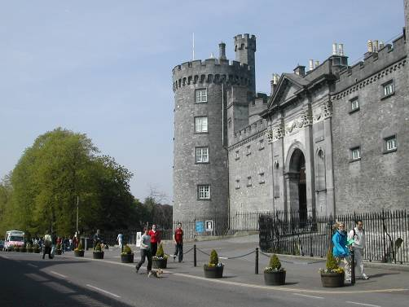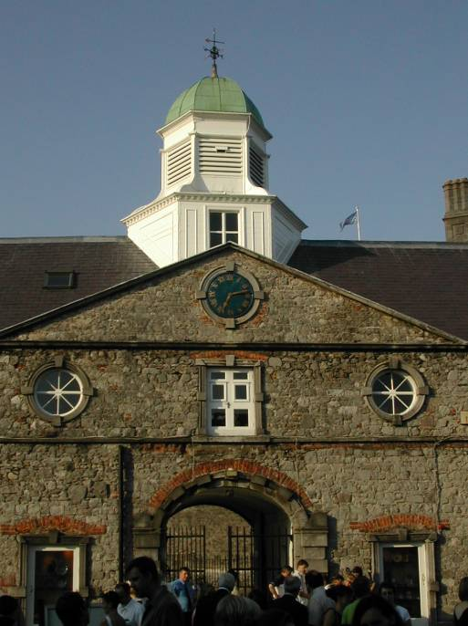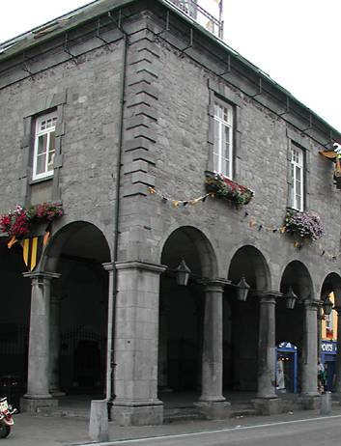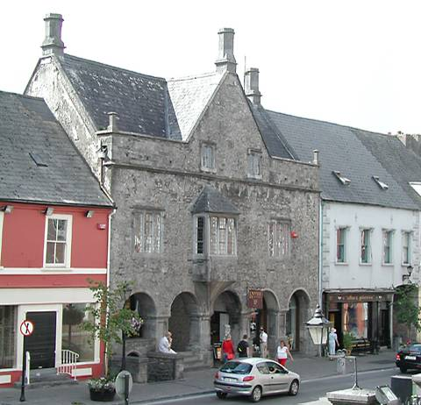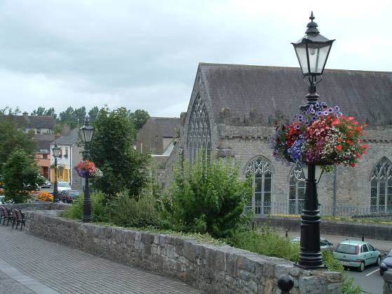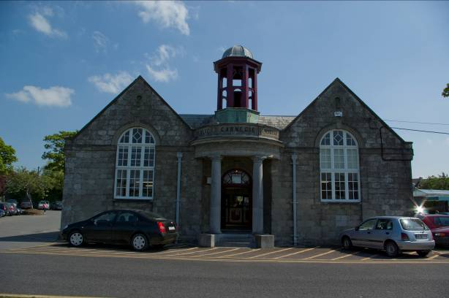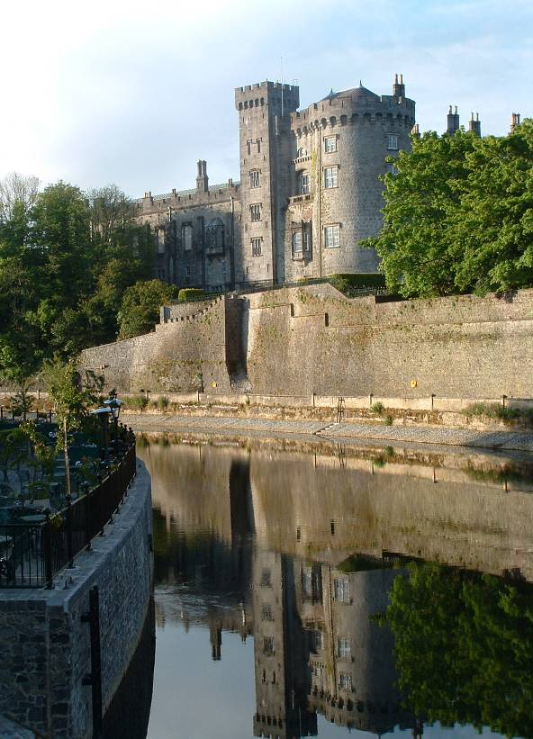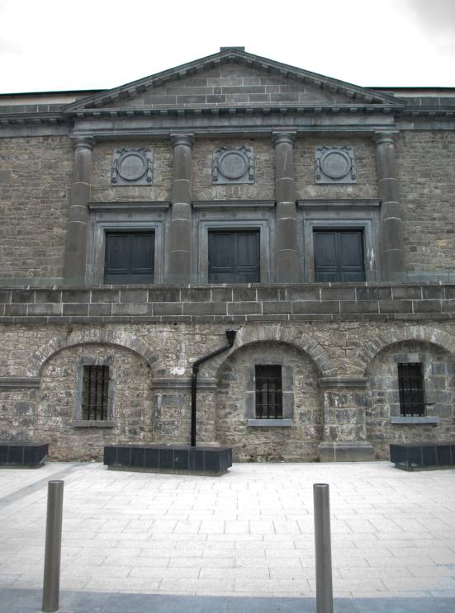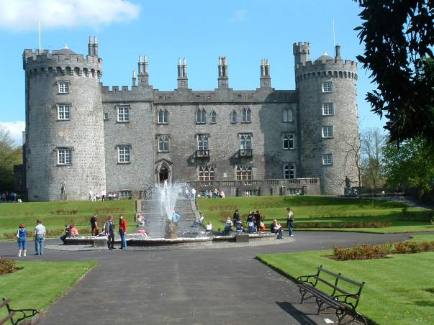5.1.1 Defining a new role for the Quarter
5.1.2 I ntegration of site into the existing Medieval fabric
5.1.3. Links to the Historic Spine / Medieval Mile
5.1.4 Public Open Spaces

5.2 Urban Framework Plan Options Considered

5.3 Final Urban Framework Masterplan
    - Phasing Proposals
    - Overall Masterplan
    - Lynchian Diagram – Post Construction
    - Site Sections
    - 3D Views

Section Six: Appendices

Appendix A Kilkenny City & Environs Development Plan 2014-2020 - Environmental and Sustainable Development Provisions
Appendix B Appropriate Assessment and Strategic Environmental Assessment Report
Appendix C Archaeological Strategy
Appendix D Flood Risk Assessment
Appendix E Spatial, Context & Process Principles
Appendix F Observations on Urban Code

