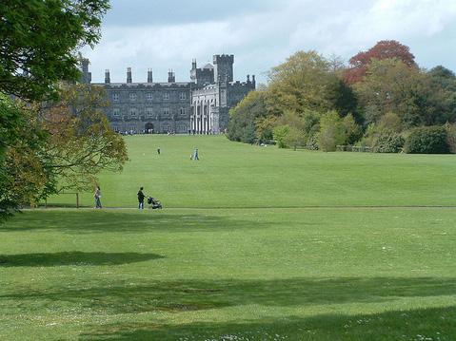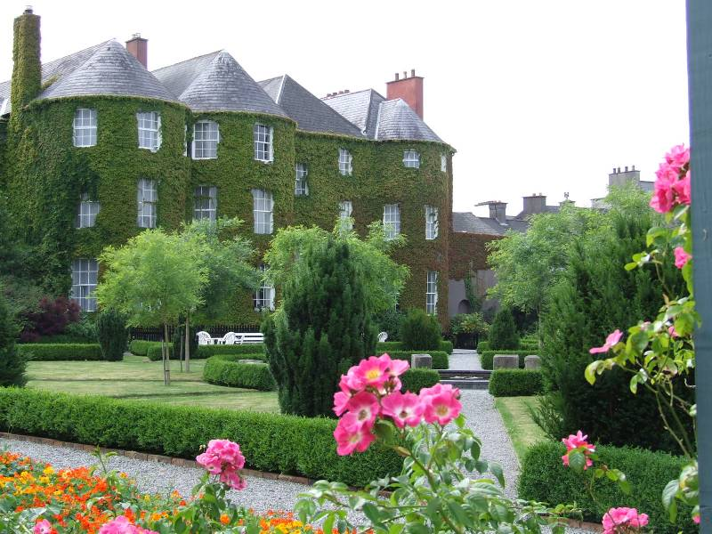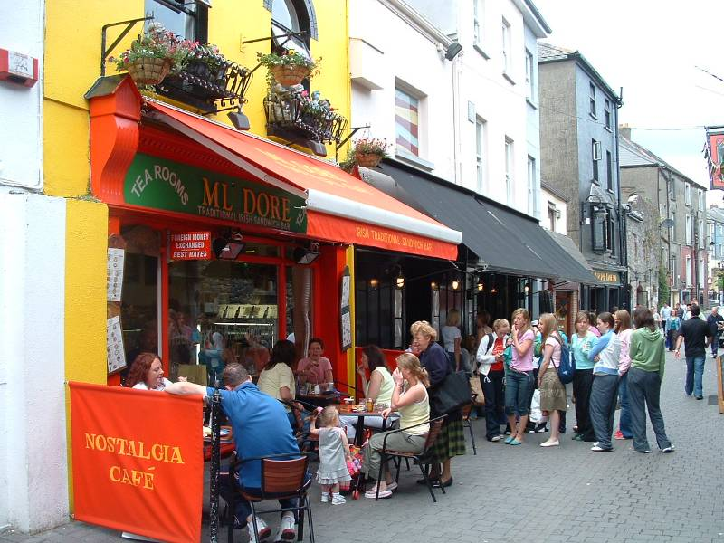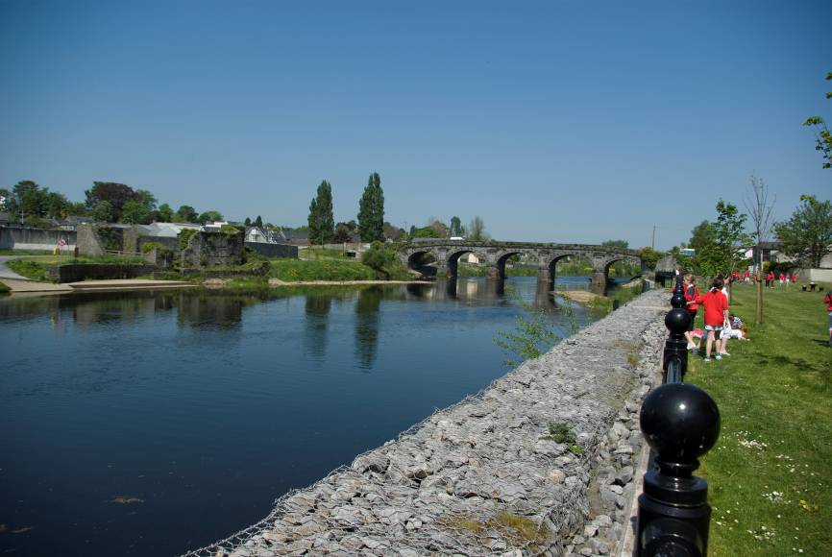

1.1 Introduction
Introduction

1.1. Introduction
1..2 Project Brief
1.3 Public Consultations
1.4 Appropriate Assessment
1.5 Strategic Environmental Assessment

1

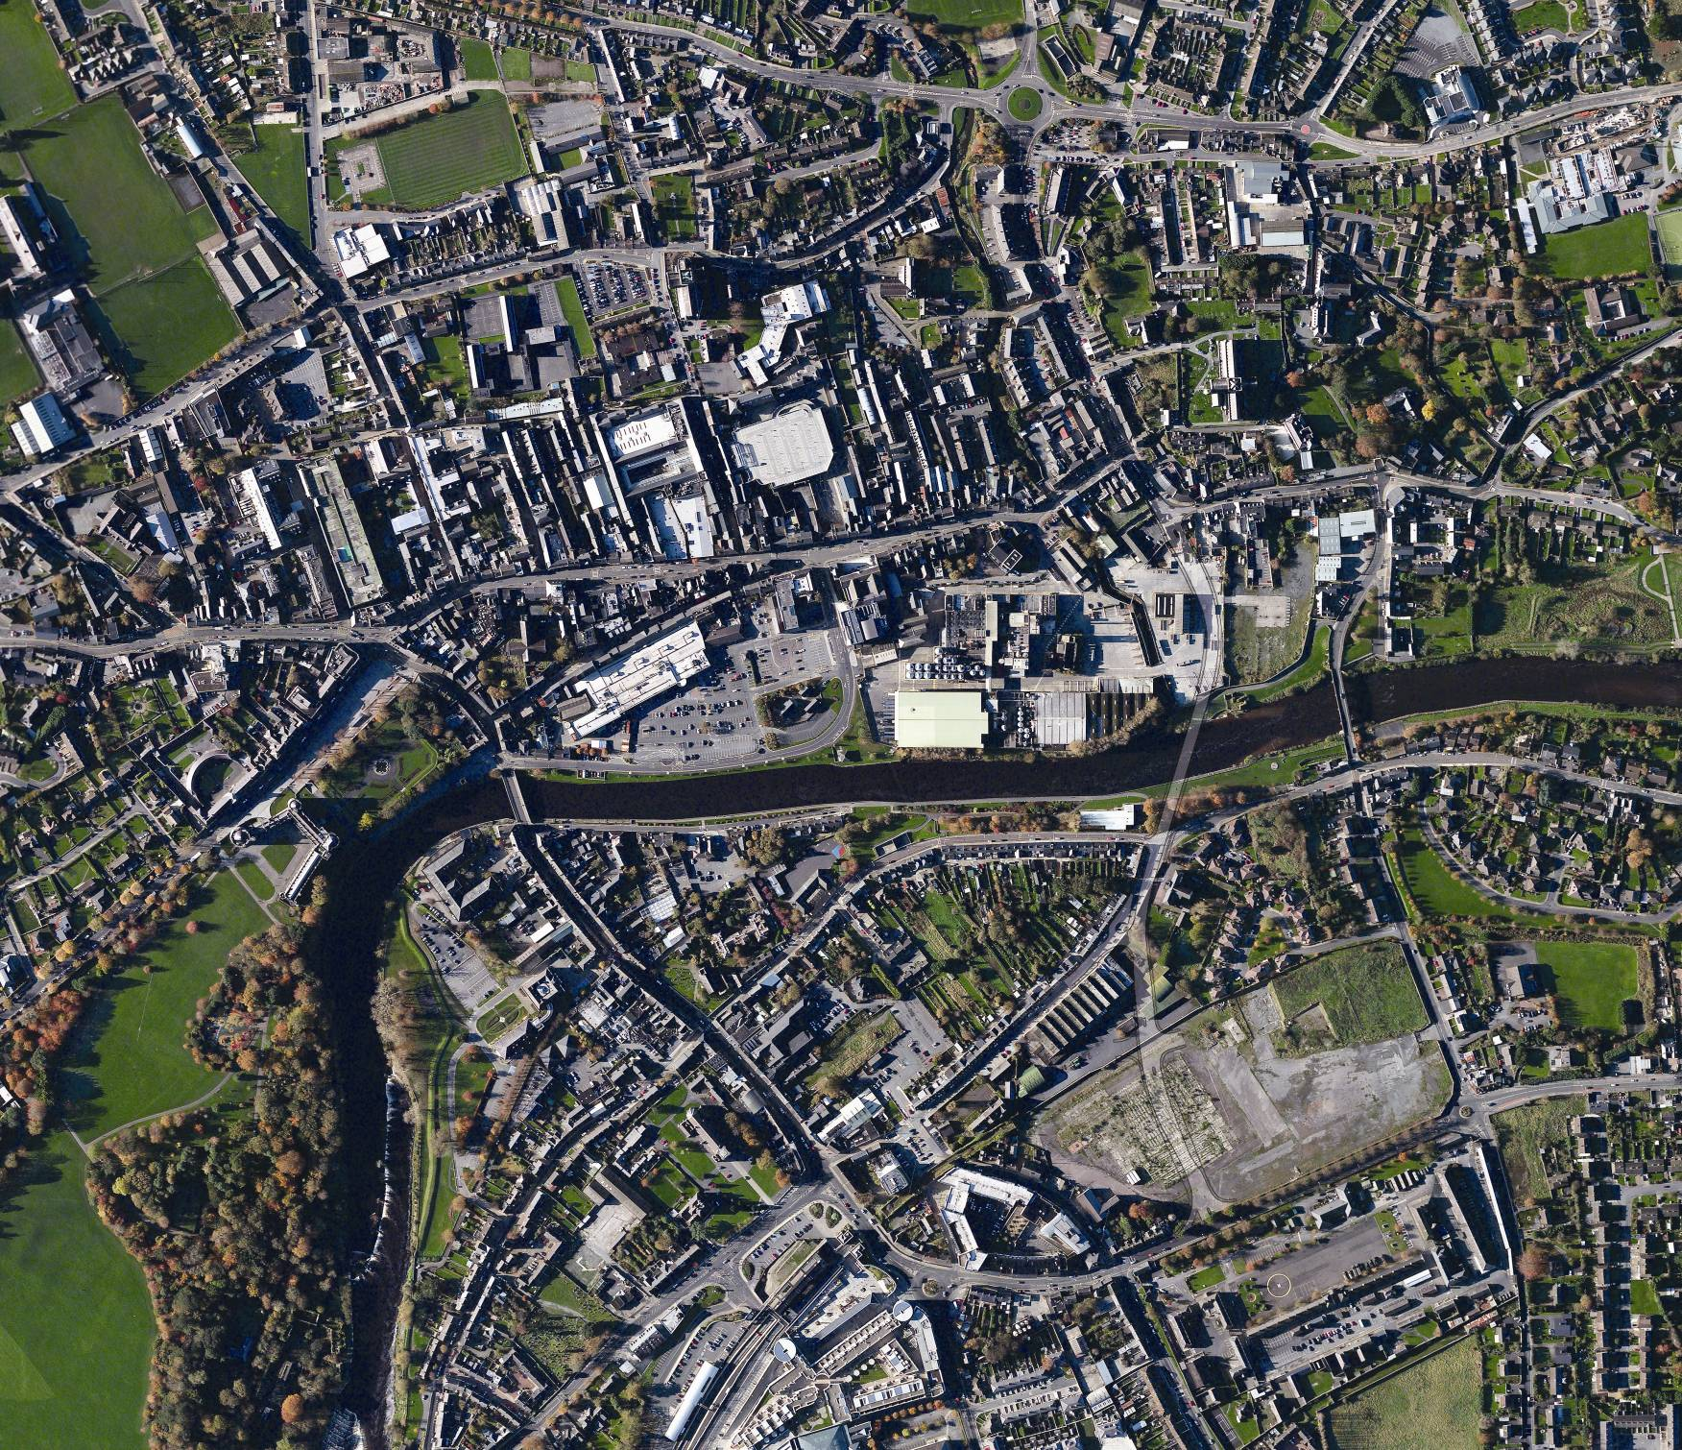
Aerial View of Kilkenny City Centre
The former Smithwicks Brewery is located on the banks of the River Nore, in the centre of Kilkenny City. The Brewery, which had been in operation for 300 years on the site, was closed by Diageo in 2013, having decided to centralise beer production at its St James’s Gate Brewery in Dublin.

A decision was made by the elected members of the Kilkenny local Authorities (Kilkenny County Council and Kilkenny Borough Council) in early 2012 to purchase the site of the Brewery from Diageo. The site was purchased with a view to job creation and the provision of public amenity areas on the site.

In order to identify options for the re-development of the site, the Royal Institute of the Architects of Ireland, (RIAI), and Kilkenny Local Authorities joined in an urban design process for the Brewery site.
Supported by the Departments of Arts, Heritage and the Gaeltacht, under the Government’s Policy on Architecture 2009-2015, a Colloquium was held in December 2012 and February 2013. This process involved eleven of Ireland’s leading architects, along with planning, engineering and property advisors.

The architects and other design and economic professionals conducted a site visit in December 2012 to determine the development potential of the site, taking into consideration the city in its totality, including its economy, history and demographics, to ensure that the development of the site delivers the best design solutions. The experts conducted a site visit in December 2012, and the identified a number of different design approaches and philosophies for consideration by the Council.

This unique partnership came up with a number of design and development concepts for the site which were unveiled in Kilkenny Castle on Thursday 2nd of May 2013.

Following this a number of architectural practices were invited to submit proposals for their approach to the overall master planning of the site, with Reddy Architecture and Urbanism commissioned in August 2013 to undertake the urban design and master planning of the site.

1.2 Project Brief

It was Kilkenny County Council’s aspiration, to create an urban design layout and architectural framework to provide a new urban mixed use quarter for Kilkenny City in a socially inclusive and sustainable manner, which will:

- Have a well defined sense of place,

- Have a healthy mix of uses including educational, employment, residential, enterprise development, recreational and community uses,

- Have suitable short to medium term uses on site while development proposals are evolving over time.

- Encourage sustainable transport with safe and direct routes for pedestrians and cyclists and provide for the availability of public transport into the city centre and connections with adjacent areas.

- Develop a framework for providing a high standard of architecture and urban design which will induce a dynamic/vibrancy to the character of the area,

- Draws from the unique natural, cultural and built heritage of the area and adds to that context,

- Have a high visual and varied environmental quality aimed at enhancing quality of life.

- Promote an awareness of the principles of sustainability in architectural design to produce buildings that are benign in the use of resources while being attractive and aesthetically pleasing.

- Be substantially achievable in a 15 to 20 year time frame.

The Council required that the framework document be neither too dogmatic nor too flexible. It would however identify certain clear principles that will be enshrined into the Kilkenny City & Environs
Development Plan 2014 - 2020. The framework document will set out core design principles that should be adhered to by all developers
in order to achieve the urban form that will deliver the vision for the area.

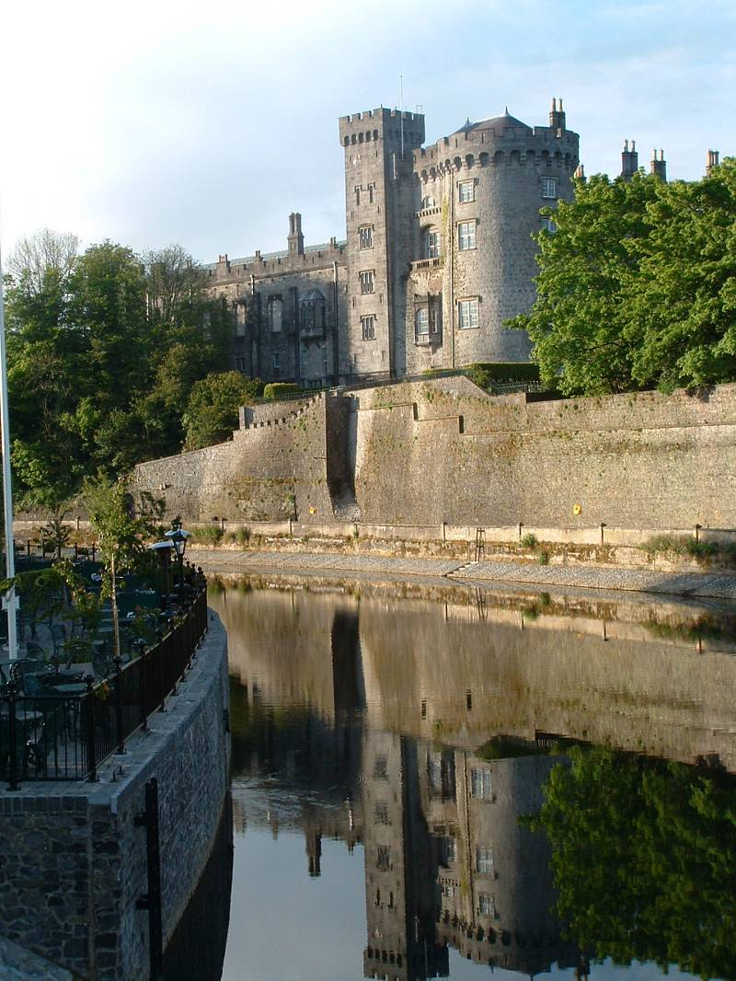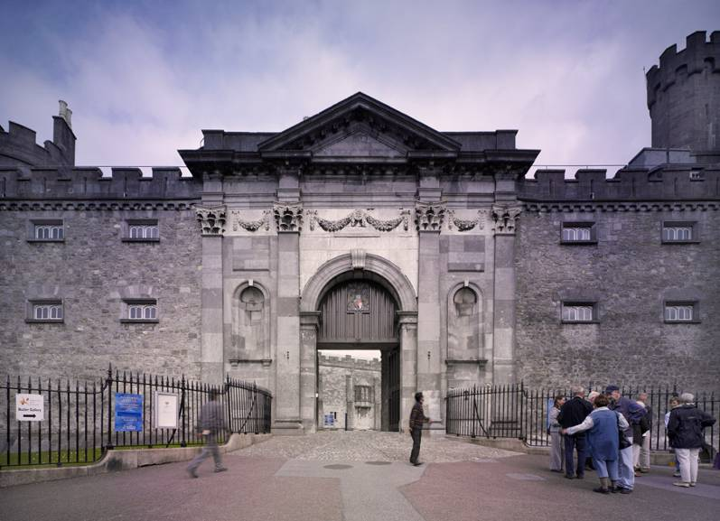
Kilkenny Castle Entrance Gate
Kilkenny Castle from Johns Bridge
1.3 Public Consultation

The process of making the Masterplan and consulting with the public and statutory authorities has been on-going since the announcement was made by Kilkenny Borough Council to purchase the Smithwick’s Brewery site in April 2012. The key dates and events over the last 3 years in this process are set out in the following table:

Date | Action
April 2012 | Announcement made that Kilkenny Local Authorities had an agreement with Diageo to purchase the Smithwick’s Brewery Site.
June 2012 | A public meeting was held by the Mayor in the Town Hall. Approximately 100 people attended an open session to discuss the future of the site.
December 2012- February 2013 | In conjunction with the Department of Arts Heritage and Gealtacht and the Royal Institute of Architects in Ireland (RIAI), a range of architects, planners and other property experts were invited to participate in a colloquium on the future of the site. An Urban Design Review Report was published as a result.
May 2013 | A special Joint Meeting of Kilkenny Borough Council and Kilkenny County Council was held to outline the results of that Urban Design Review. Following the colloquium and urban design review, tenders for consultants to prepare a Masterplan were issued.
July 2013 | Reddy Architecture and Urbanism were appointed to prepare the Masterplan.
 | A joint meeting of the County Council and the Borough Council was held in July 2013 at which the decision to retain and refurbish the Mayfair and Brewhouse buildings and to temporarily retain the Maturation building was made to support early interest in business start-ups.
November 2013 | A draft Masterplan document was published in November 2013 and submissions were received by the Council up to 13th December. A public meeting was held in the Town Hall on the 5th November presenting the draft Masterplan. 38 submissions were received to the initial draft Masterplan from members of the public and statutory authorities.
November 2014 | Following these consultation events, a Chief Executive’s report was brought to the County Council in November 2014.  The Chief Executive’s report recommended the retention of the Mayfair & Brewhouse buildings, the creation of a linear park by the river Nore, the creation of a street to link Bateman Quay and the Central Access Scheme and to engage in further public consultation to revision the Masterplan.
January 2015 | The Planning Department of Kilkenny County Council embarked on a public consultation exercise in January 2015 called ‘The Brewery: Re-Visioning’. Members of the public were invited to attend a two-day public event to express their views and suggestions for the future development of the brewery site through a workshop format. Due to the high level of interest from members of the public, a second two-day workshop was organised. A half day workshop with Comhairle na nÓg was also held. 222 people participated in these workshops. The work focused on Visioning the area and Guidelines to implement the vision. The Council also received 71 written submissions during this consultation period.
March 2015 | A Chief Executive’s Report was published outlining the issues raised and the work carried out at the workshops. This is published on http:\\ourplan.kilkenny.ie . A Vision Statement and suggested Guidelines were put forward as a direct result of the consultation workshops. The report also included a suite of recommendations on the process, such as completing a detailed archaeological strategy, environmental assessments and to hold a further feedback public event.
May 2015 | Following completion of the Archaeological Strategy and the draft Environmental Reports, a Feedback and Public Engagement event was held on the 16th of the May 2015. A total of 54 people attended this follow-up session. An emerging draft Masterplan layout was presented having regard to the archaeological and environmental reports, and to the changes made on foot of the public consultation events. Members of the public carried out a SWOT analysis (Strengths, Weaknesses, Opportunities & Threats) of the emerging Masterplan layout. A report outlining the work carried out at this event is also published on http:\\ourplan.kilkenny.ie
 | A special Council meeting was held on the 27th of May to discuss the Draft Masterplan for the Abbey Creative Quarter. The Council approved the Draft Masterplan for public display. A proposed Variation to the Kilkenny City & Environs Development Plan 2014-2020 to enshrine high level principles for the Masterplan area was approved to proceed to public consultation.
June/July 2015 | The Draft Masterplan with draft Strategic Environmental Report (SEA), Appropriate Assessment (AA) and Archaeological Strategy were placed on public display on the 23rd June for a period of 4 weeks and circulated to statutory agencies, government departments and relevant stakeholders for consultation.

This exrtensive consulatation programme has informed the preparation of the masterplan.

1.4 Appropriate Assessment

The Abbey Quarter Masterplan is a non-statutory plan being prepared in the context of the Kilkenny City & Environs Development. The City Plan has an objective to prepare a masterplan/framework document for the development of the Smithwicks Brewery site and Bateman Quay.

An Appropriate Assessment has been carried out for the Kilkenny City and Environs Development Plan 2014-2020.

What is an Appropriate Assessment

The obligation to undertake Appropriate Assessment derives from Article 6(3) and 6(4) of the Habitats Directive 92/43/EEC. An Appropriate Assessment is a focused and detailed impact assessment of the implications of a strategic action or project, alone and in combination with other strategic actions and projects, on the integrity of a Natura 2000 site (a candidate Special Area of Conservation or a Special Protection Area) in view of its conservation objectives.

The key sites considered by the Appropriate Assessment of the revisioned Masterplan included the River Barrow and Nore candidate Special Area of Conservation (Site Code: 002162) and the River Nore Special Protection Area (Site Code: 004233), (Natura 2000 site.)

The detailed findings of the assessment are contained in a Natura Impact Report which is located at Appendix B of the Masterplan.

Appropriate Assessment Summary

The assessment demonstrated that the implementation of the Masterplan has the potential to result in adverse impacts to the integrity of the Natura 2000 network of sites, if unmitigated.

The risks to the safeguarding and integrity of the qualifying interests and conservation objectives of the Natura 2000 network have been addressed by integration of measures into the Masterplan that will prioritise the avoidance of impacts in the first place and otherwise mitigate impacts where these cannot be avoided. In addition, all lower tier projects arising through the implementation of the Masterplan will themselves be subject to an Appropriate Assessment when further details of design and location are known.

Having incorporated these suggested mitigation measures; it is considered that the Masterplan will not impact on the Natura 2000 network of sites³.

³ Except as provided for in Section 6(4) of the Habitats Directive, viz. There must be:
a) no alternative solution available,
b) imperative reasons of overriding public interest for the plan to proceed; and
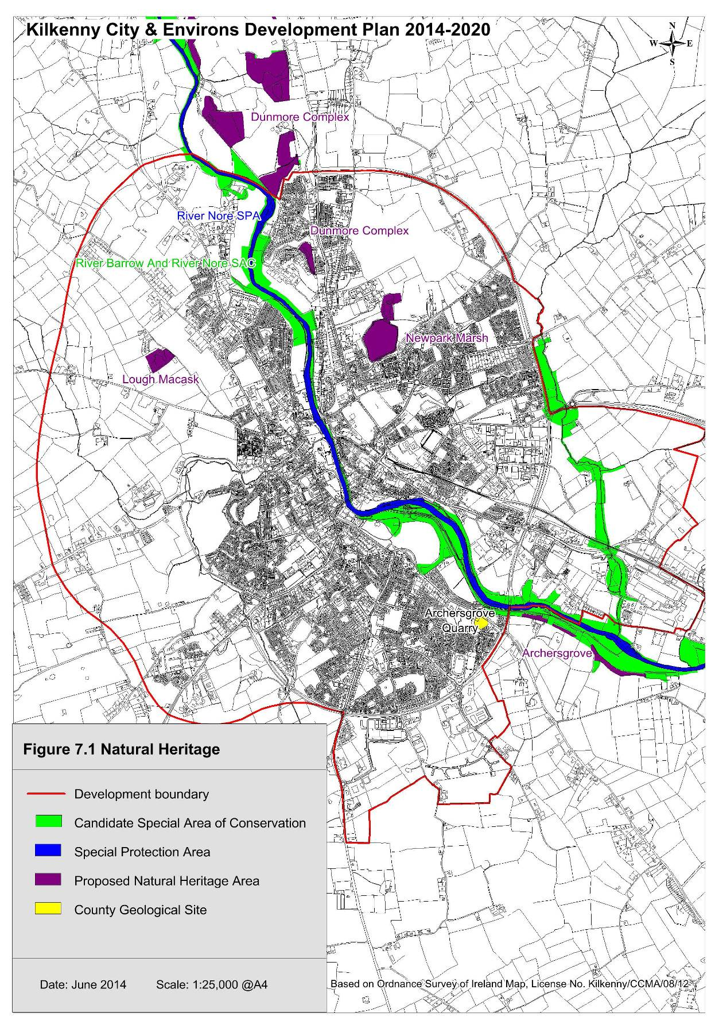c) Adequate compensatory measures in place.
Natura 2000 / Heritage Map Kilkenny City Centre

Mitigation for Masterplan

The Masterplan will support the protection of habitats and species listed in the annexes to and/or covered by the EU Habitats Directive (92/43/EEC, as amended) and Birds Directive (2009/147/EC) and species protected under the Wildlife Acts 1976-2000 and the Flora Protection Order.

The River Nore and River Breagagh are located within European sites (River Barrow and Nore cSAC and River Nore SPA) that form part of the Natura 2000 network. Prior to commencement, any development that could potentially impact on these sites must be subject to Screening for Appropriate Assessment as required under Article 6 of the EU Habitats Directive.

Given the degree of protection afforded to areas subject to Natura 2000 designation, these have been identified on all Masterplan proposal drawings.

This Masterplan requires that:

- All projects and plans arising from the Masterplan will be screened for the need to undertake Appropriate Assessment under Article 6 of the Habitats Directive. A plan or project will only be authorised after the Council has ascertained, based on scientific evidence, Screening for Appropriate Assessment, and a Stage 2 Appropriate Assessment where necessary, that:

  - The Plan or project will not give rise to significant adverse direct, indirect or secondary effects on the integrity of any European site (either individually or in combination with other plans or projects); or

  - The Plan or project will have significant adverse effects on the integrity of any European site (that does not host a priority natural habitat type/and or a priority species) but there are no alternative solutions and the plan or project must nevertheless be carried out for imperative reasons of overriding public interest, including those of a social or economic nature. In this case, it will be a requirement to follow procedures set out in legislation and agree and undertake all compensatory measures necessary to ensure the protection of the overall coherence of Natura 2000; or

  - The Plan or project will have a significant adverse effect on the integrity of any European site (that hosts a natural habitat type and/or a priority species) but there are no alternative solutions and the plan or project must nevertheless be carried out for imperative reasons for overriding public interest, restricted to reasons of human health or public safety, to beneficial consequences of

  - primary importance for the environment or, further to an opinion from the Commission, to other imperative reasons of overriding public interest. In this case, it will be a requirement to follow procedures set out in legislation and agree and undertake all compensatory measures necessary to ensure the protection of the overall coherence of Natura 2000.

- No projects giving rise to significant cumulative, direct, indirect or secondary impacts on Natura 2000 sites arising from their size or scale, land take, proximity, resource requirements, emissions (disposal to land, water or air), transportation requirements, duration of construction, operation, decommissioning or from any other effects shall be permitted on the basis of this Masterplan (either individually or in combination with other plans or projects⁴)

Proposals for development within the Masterplan area must comply as appropriate with the relevant provisions included within the Kilkenny City Development Plan 2014-2020. A number of City Plan provisions which contribute towards environmental protection and sustainable development are reproduced in Appendix B.

- Proposals for development should ensure that they are consistent with all the provisions contained within the City & Environs Development Plan.

⁴ Except as provided for in Section 6(4) of the Habitats Directive, viz. There must be:
a) no alternative solution available,
b) imperative reasons of overriding public interest for the plan to proceed; and
c) adequate compensatory measures in place.
These rivers are partly designated within the Natura 2000 Network.

1.5 Strategic Environmental Assessment

What is SEA?

The obligation to undertake Strategic Environmental Assessment (SEA) derives from the SEA Directive 2001/42/EC. SEA is a systematic process of predicting and evaluating the likely environmental effects of implementing a proposed plan, or other strategic action, in order to ensure that these effects are appropriately addressed at the earliest appropriate stage of decision-making on a par with economic, social and other considerations.

The findings of the assessment are contained in a SEA Environmental Report which accompanies the revisioned Masterplan and contains the following information:

- A description of the environment and the key environmental issues;
- A description and assessment of alternatives for the Masterplan;
- An assessment of the provisions of the Draft Masterplan; and,
- Mitigation measures which set out to aid compliance with important environmental protection legislation - e.g. the Water Framework Directive, the Habitats Directive - and which will avoid/reduce the environmental effects of implementing the Masterplan.

On adoption of the Masterplan, an SEA Statement will be prepared which will summarise, inter alia, how environmental considerations have been integrated into the Masterplan.

The findings of other processes are integrated into the SEA:
- Appropriate Assessment;
- Strategic Flood Risk Assessment;
- Archaeological and Heritage Strategy;
- Connectivity and Movement Strategy;
- Sustainability Strategy; and
- Urban Design Strategy.

The overall findings of the SEA are that:

- The Council has integrated all recommendations arising from the SEA, Appropriate Assessment and Strategic Flood Risk Assessment processes into the Masterplan, facilitating compliance of the Masterplan with various European and National legislation and Guidelines relating to the protection of the environment and the achievement of sustainable development;

- Some Masterplan provisions would be likely to result in significant positive effects such as contributions towards achieving sustainable mobility and the protection of ecology, archaeological heritage and the status of waters.

- Some Masterplan provisions would have the potential to result in significant negative environmental effects however these effects will be mitigated by the mitigation measures which have been integrated into the Masterplan.

Emerging Mitigation

As detailed above, the findings of various other processes, some of which have been in train since the beginning of the Masterplan preparation process, will be incorporated into the SEA. This will include details on the various environmental mitigation measures which have been integrated into the Masterplan.

Integration of Environmental Considerations into the Masterplan

Introduction

The Masterplan has been prepared with environmental considerations being one of the key Masterplan informants and influences.

The undertaking of Strategic Environmental Assessment, Appropriate Assessment and Strategic Flood Risk Assessment has further informed the Draft Masterplan. New development will have to comply with the provisions of the Masterplan including those which are detailed below.

Masterplan Strategies

The text of the Masterplan outlines how the various Strategies in the Masterplan will contribute towards environmental protection and sustainable development.

Kilkenny City & Environs Development Plan 2014-2020 Provisions

Proposals for development within the Masterplan area must comply as appropriate with the relevant provisions included within the Kilkenny City & Environs Development Plan 2014-2020. A number of City Plan provisions which contribute towards environmental protection and sustainable development are reproduced in Appendix A. Proposals for development should ensure that they are consistent with all the provisions contained within the City Plan.

Issues considered include: biodiversity and flora and fauna; population and human health; soil; water; air and climatic factors (including sustainable mobility); material assets; cultural heritage (including archaeological and architectural heritage); and landscape.

