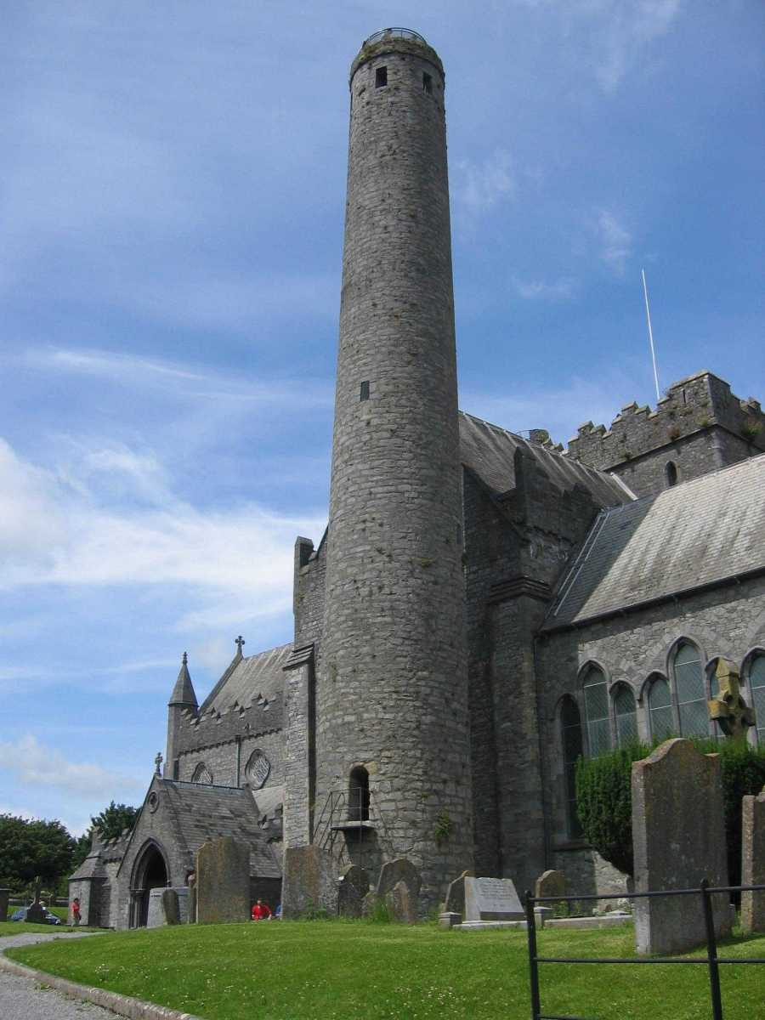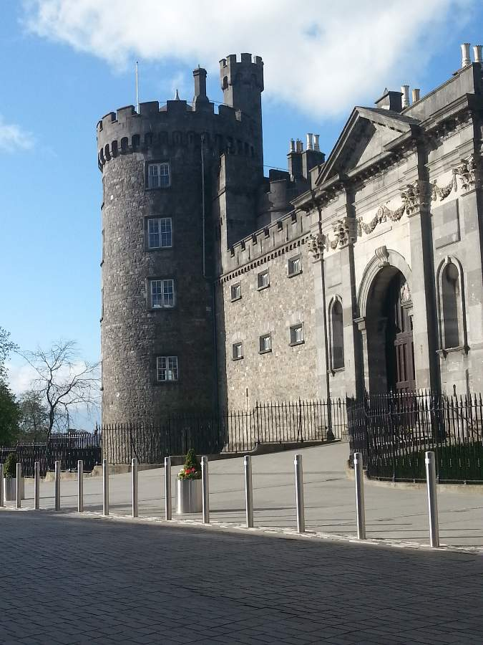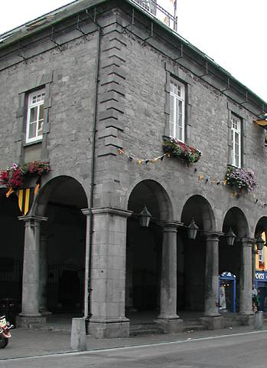

2.2
Context of Kilkenny

2.2.1 Vision arising from Public Consultation
2.2.2 Kilkenny attracting New Industries

2.2.1 Vision arising from Public Consultation Workshops

The Councils seek continually to develop the city as a centre of excellence for creativity in all sectors whilst ensuring the continued protection and enhancement of the city’s magnificent built and natural heritage, its thriving cultural and artistic base and its strong and dynamic services economy. This will ensure that the city will be a vibrant and attractive place for people to visit, work and live in.

The followung vision statement was developed from the work that was carried out at the Public Consultation Workshops held in January 2015.

“To plan the area as a seamless complement to the medieval city as an inclusive place for an inter-generational community to work, live, visit and play with St. Francis Abbey at its core. The regeneration of the area will focus on embracing the sites’ natural, cultural and built heritage, whilst maximising the benefits of the rivers Nore and Breagagh, providing for a broad range of uses, sustaining growth in employment and advancing economic activity in a sustainable and energy efficient fashion where innovation can flourish. The area will be a permeable expansion of the city for pedestrians and cyclists where smarter travel principles are provided for.”

The following objectives are fundamental to achieving that vision;

- Integration of former Smithwick’s Brewery site and riverside into the medieval city.

- Redevelop and regenerate the former Smithwick’s Brewery site as a modern, vibrant and permeable complement to the medieval core of Kilkenny City which will consolidate the city’s role as a regional hub.

- Creation of a quayside quarter which addresses the River Nore

- Establishment of a mixed use Creative Quarter which enhances the Life of the City in Economic, Commercial and Social Terms

- Development of Kilkenny as a location for Creative Industries, Research and Development, Incubation Clusters, University Faculties and Cultural Institutions

- Establishment of ‘Green City’ Kilkenny as a model for Irish and European cities and communities

- Allow for the Government ‘Smarter Travel’ initiative published in 2009 and the ‘Mobility Management Plan’ adopted for Kilkenny City.

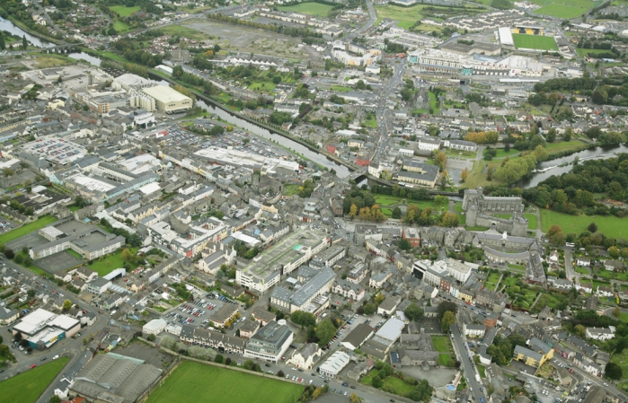

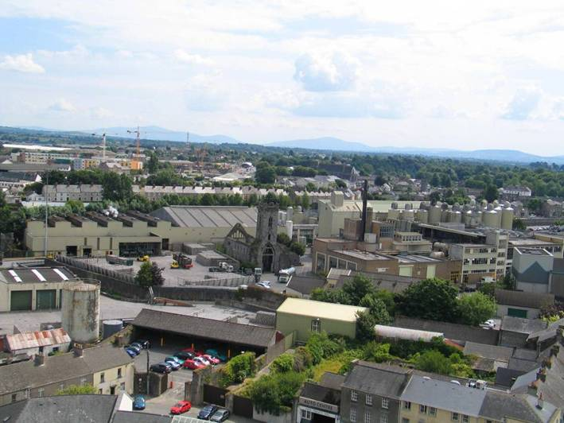

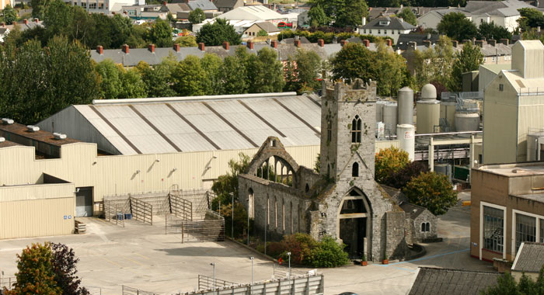

2.2.2 Kilkenny, attracting new industries for living and working

In the post industrial era, the most attractive urban environments have been those that established an attraction for creative industries. American Sociologist Richard Florida has identified creative
industries as those which involve technology workers, professional services, artists, musicians and knowledge based industries. He suggests that this ‘creative class’ fosters an open, dynamic, personal
and professional environment which in turn, attracts more creative people as well as economic vitality.

This development can successfully take place in interesting cities with a strong urban identity and good amenities which offer long term prosperity.

Kilkenny, while smaller than many Irish cities, nevertheless has all the characteristics of a much larger city including a medieval core, high quality public realm, an attractive setting and a strong cultural base. These attributes give Kilkenny a significant edge in competing as a destination for creative and knowledge based industries in the
future. With the Former Smithwick’s Brewery site on the banks of the River Nore, presenting the possibility of providing accommodation for such companies at the heart of the urban core.

