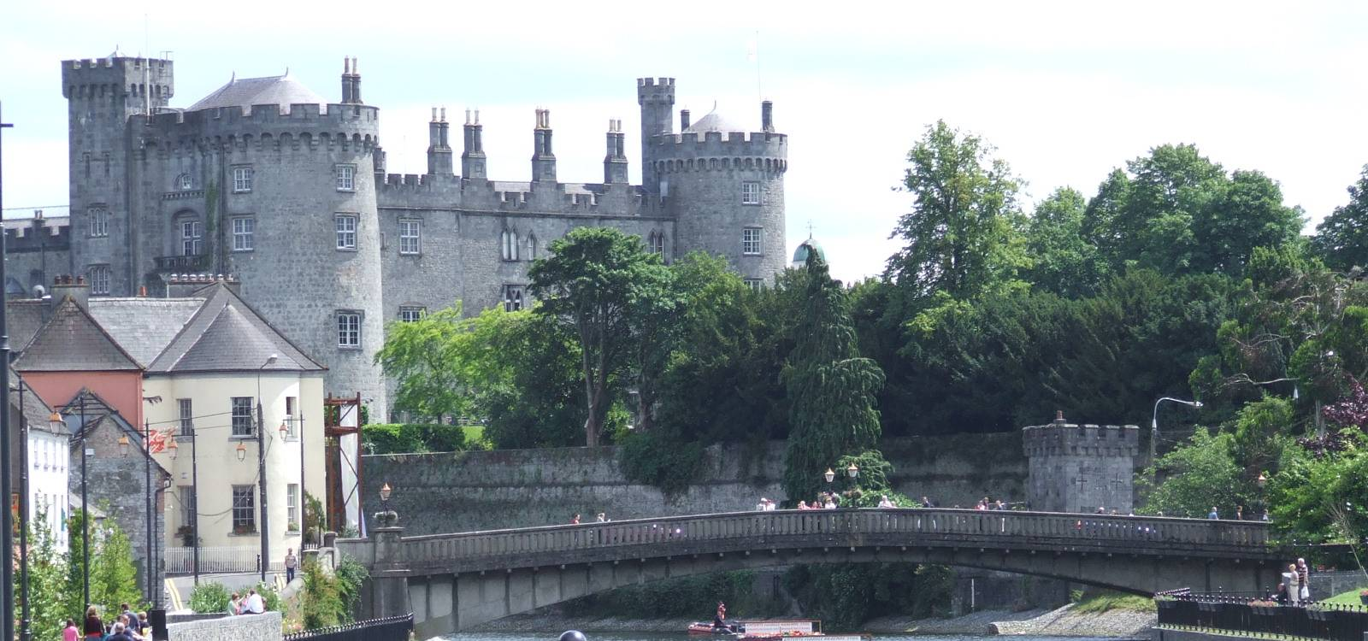

**3.2**

Urban Planning & Analysis

3.2.1 Site Analysis – Lynchian Method

3.2.2 Opportunities , Strengths and Weaknesses

3.2.3 Context

**3.2.1 Site Analysis Lynchian Method**

Analysis of existing urban area using the method of urban planner Kevin A. Lynch (1918 - 1984 ). He was an American urban planner and author. His most influential books include The Image of the City (1960) and What Time is This Place? (1972).

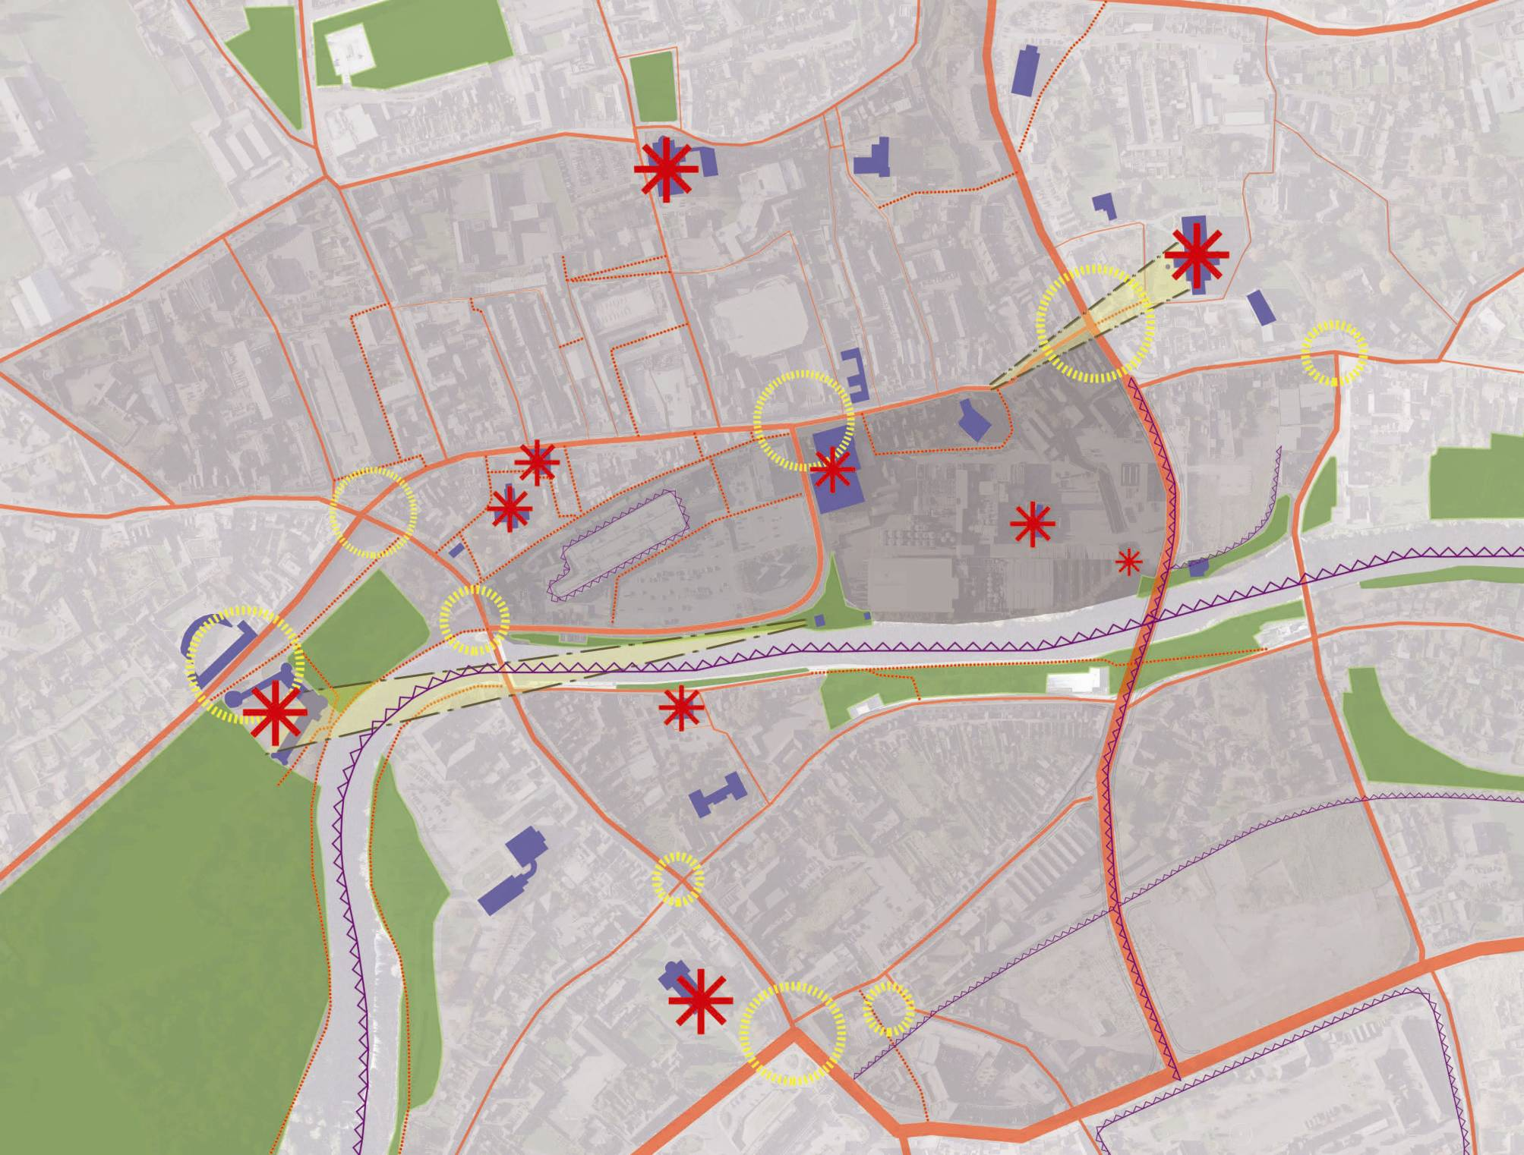

Kevin Lynch provided seminal contributions to the field of city planning through empirical research on how individuals perceive and navigate the urban landscape. His books explore the presence of time and history in the urban environment, how urban environments affect children, and how to harness human perception of the physical form of cities and regions as the conceptual basis for good urban design. He used simple sketches of maps created from memory of an urban area to reveal five elements of the city; nodes, edges, districts, paths and landmarks. The creation of a mental map relies on memory as opposed to being copied from a pre-existing map or image.

This map outlines the Public Buildings, Landmarks, Nodal Points, Vistas, Barriers, Roadways, Pedestrian routes, Districts and Green spaces. The resulting analysis shows the Brewery site at the heart

of the development containing landmark buildings with no public access or permeability through to these areas or through the site.

**3.2.2 Opportunities and Weaknesses**



Public Buildings

Landmarks

Node / Focal Points

Vistas from St.Francis Abbey

Barriers

Pesestrian Routes

Roadways

Disticts

Public Green Space

A SWOT Analysis of the Masterplan Area was carried out by Kilkenny County Council. This analysis assists in guiding urban planning by

maintaining a focused, long-term vision for the masterplan area , which aids decision making about the urban development. The review and understanding of the masterplan area , its strengths and weaknesses are of major importance in the strategic planning of Kilkenny City. Awareness of the strengths and weaknesses, opportunities and threats are a necessity for urban development plans and programs.

**Opportunities**

Conditions that are helpful in achieving the stated objectives

* Size of the site to consolidate the city centre.
* Potential for a third level education institution.
* Potential for exemplar ‘green city’/sustainable buildings.
* Complete the River Nore linear park.
* To utilize the River Nore for water based activities and amenity.
* Cultural significance and heritage value of site.
* Bring St. Francis Abbey and the City Wall/Evan’s Turret back into the public realm.
* Archaeological finds.
* Enhance the public realm by introducing a large well designed public open space.
* City centre family living.
* Employment generation.
* Implement Smarter Travel Policy.
* Deliver a city skate park.
* Establish / Open up new city vistas.
* To maximize the potential of the Watergate Theatre.

**Strengths**

Attributes of the masterplan area that are helpful in achieving the stated objectives.

* The site is substantial in area and enjoys a remarkable geographic position and orientation within the city.
* It’s setting - immediately adjoining the River Nore and River Breagagh.
* Includes several existing heritage structures of national importance.
* The line of the old city wall traverses the site.
* Several of the existing buildings on the site are suitable for refurbishment and conversion to new uses.
* Adjacent to retail core.
* All parts of the city are within walking distance

**Weaknesses / Threats**

Attributes of the masterplan area that are harmful in achieving the stated objectives.

* Though surrounded by the city the site has few physical links with the city
* While immediately adjoining the River Nore and River Breagagh the site does not currently have a relationship to either river
* Robust flood relief measures are in place with a residual risk of flooding
* Fragmented nature of the masterplan area.
* Site remediation.
* Sequential development of other key city sites.
* Traffic movement / the car.
* May detract from the existing city centre.
* Potential dereliction associated with slow pace of development.

**3.2.3 Context**

From a historical context, both for Kilkenny City and in the wider sphere of the evolution of a European medieval city, the opportunity offered by the vacating of St.Francis Abbey Brewery from this site is unique for the aspiration to realise the following;

* The stitching back together of the heart of a city that is sympathetic to its individual character, whilst providing for the needs of a modern thriving urban environment, in terms of education, cultural, office, retail and residential provision.
* The possibility of Kilkenny city turning to face the river Nore in a meaningful way, to bring the amenity and aesthetic value of the waterfront into the heart of the city.
* The continuation of the River Nore green route through the city.
* The ability to rejuvenate Irishtown and bring balance to the city.

