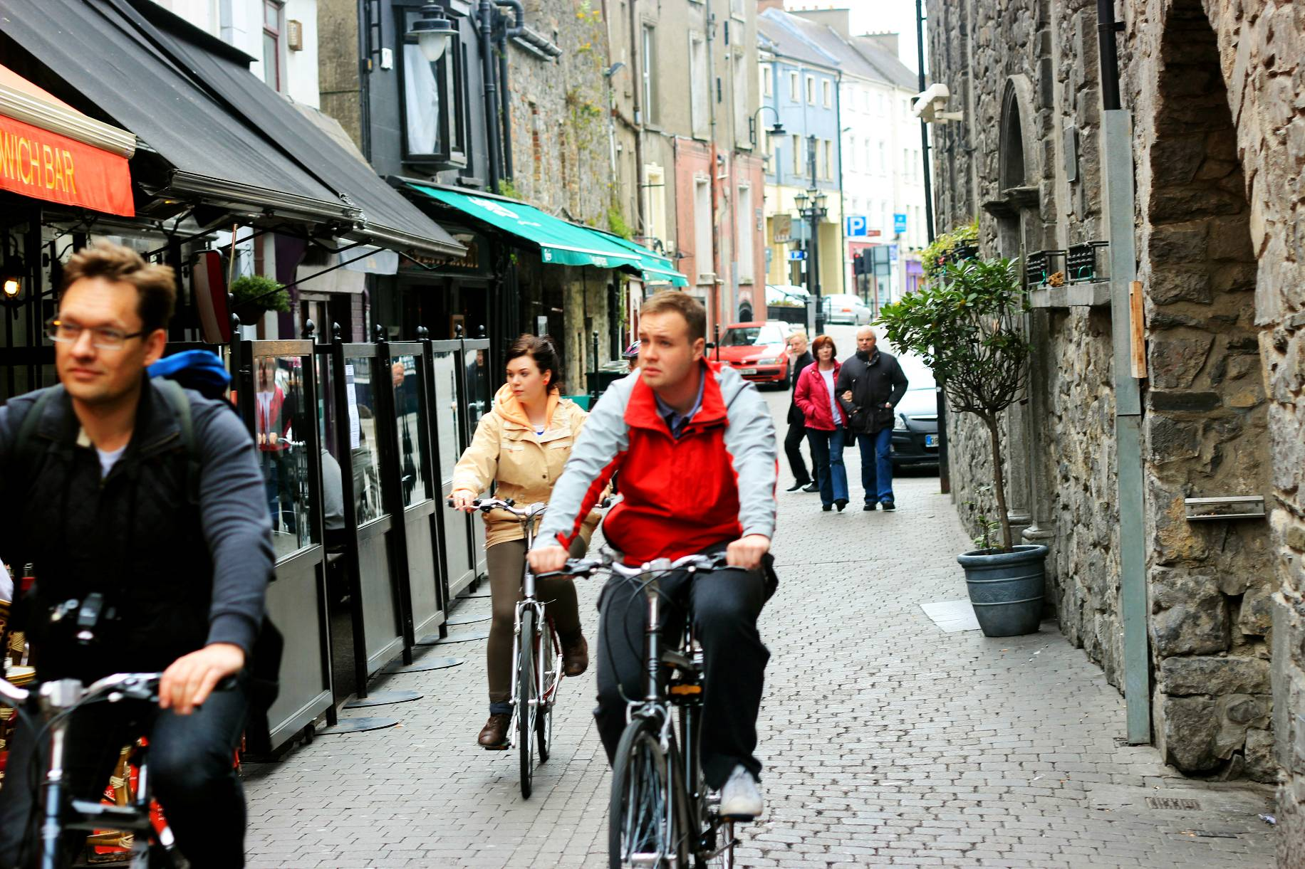

4.1
Connectivity and Movement Strategy

4.1.1 Smarter Travel / Mobility Management Plan
4.1.2 Key Connectivity and Movement Issues
4.1.3 Pedestrian & Cyclist Movement
4.1.4 Vehicular Movement
4.1.5 Public Transport
4.1.6 Parking / Traffic Management

4.1.1 Smarter Travel / Mobility Management Plan

‘Smarter Travel’ is a Government initiative published in 2009 which sets out policies for a sustainable transport future. The main objectives are:
- To encourage smarter travel, i.e. to reduce overall travel demand
- To maximise the efficiency of the transport network
- To reduce reliance on fossil fuels and therefore to reduce transport emissions
- To improve accessibility to transport.

In 2009, a Mobility Management Plan was adopted for Kilkenny city. The purpose of this Plan was to establish a formal mobility and traffic management plan dealing with transport modal shift and accessibility. A number of proposals were included in this Plan covering cycling, parking, traffic management and bus services.

In supporting the objectives of the Mobility Management Plan, this masterplan aims to create a pleasant pedestrian environment in the city. This brings enormous benefits, in terms of tourism, the economy, and to quality of life. In line with Smarter Travel, the master plan will facilitate cycling and walking by providing a network of safe, well-lit and convenient pedestrian and cycle routes within the site which will encourage such modes of transport. Routes will be designed to be connected, convenient, comfortable, and conspicuous.

4.1.2 Key Connectivity and Movement Issues

As with all urban areas, streets are needed in an urban context to provide permeability into areas of development and connectivity and ease of movement within the area.

In the case of the St Francis Abbey Brewery Site, access to the site is required to :

- Provide access for the people of Kilkenny and tourists alike to the historic monuments that exist on the site and to the future amenity, residential and commercial facilities that may be developed on the site.
- Provide access for residents.
- Provide access for people working in the area.
- Provide access for deliveries to residential, commercial and other properties in the area.
- Provide access for Emergency Vehicles to the site.

In considering access requirements, various modes of transport need to be accommodated:

- Pedestrians incl. Wheelchair users, prams/buggies etc
- Cyclists.
- Cars.
- Light Goods vehicles.
- Service Vehicles.

The level of permeability that should be afforded to each of these users needs to be considered in the layout of the Masterplan Area.
4.1.3 Pedestrian & Cyclist Movement
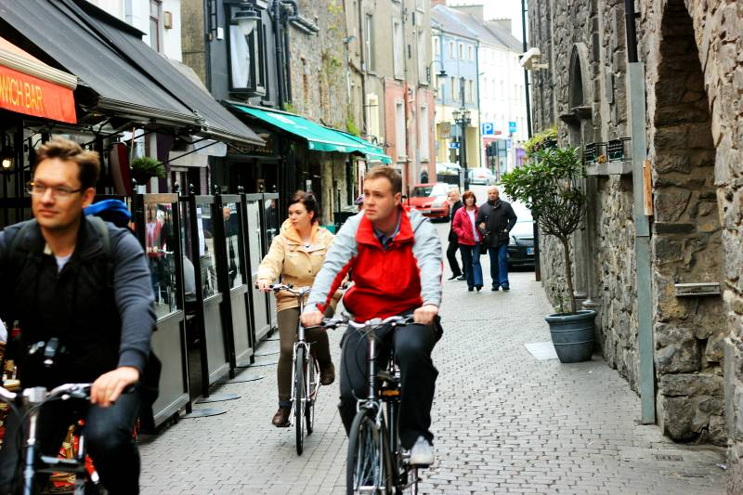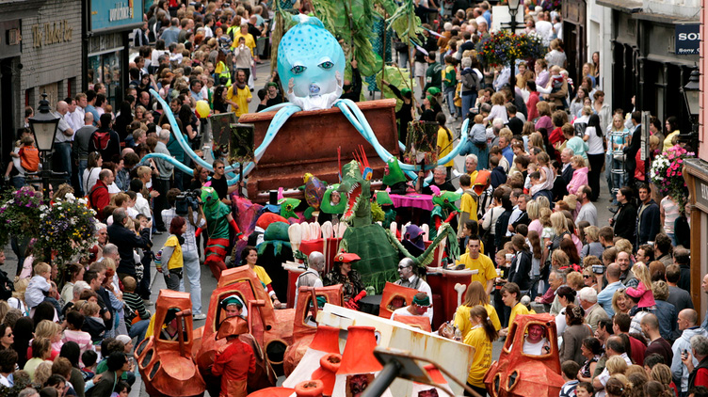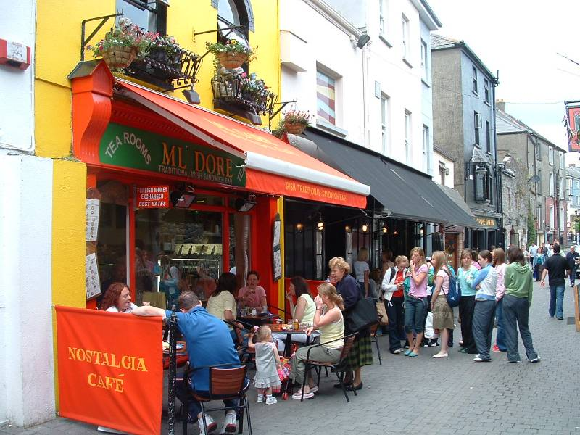
The city centre contains the core retail area and main tourist trails accordingly priority in these areas should be afforded to pedestrians. The recent improvements to the footpaths and streetscape in High St through the Medieval Mile project help to promote and assist pedestrian movements in the city centre area.

In the Masterplan area, it is intended that movement will be dominated by pedestrians and cyclists, with limited vehicular access. This will help to create a vibrant and sustainable place, providing the area with an important sense of place.

Any areas where vehicles are allowed within the Masterplan area will be designed as shared spaces. Such spaces are integrated spaces , where pedestrians, cyclists and vehicles share the carriageway, and are considered to be highly desirable where pedestrian activities are high and vehicles movements are only required for lower level access or circulatory purposes.¹

A key element of new linkages is the provision of pedestrian and cycle linkages on both the east and west banks of the river. These will serve as both amenity routes and access routes to the city centre. As amenity routes, they will form part of long distance amenity routes along the Nore, completing the missing link in the River Nore Linear Park. Within the urban area of the City they will provide ideal short and longer distance walking routes along the river incorporating the existing bridges, the Central Access Scheme Bridge, and the new pedestrian bridge at John’s Quay.

Kilkenny is a relatively flat and compact City with a significant proportion of its population living within two kilometres of the City Centre. These characteristics contribute towards making Kilkenny City an ideal location for commuting to work or school by foot or bicycle.

Key to the delivery of a successful cycle network is the provision of a complete supporting infrastructure. This includes providing secure cycle parking facilities at popular destinations such as The Parade, Johns Green, Bateman Quay and High Street. Cycle parking facilities will be provided at suitable locations within the Masterplan site.

¹ Design Manual for Urban Roads and Streets published by the Dept. of
Transport and the Dept. of Environment, community & Local Govt.

4.1.4 Vehicular Movement

While it is intended that movement through the Masterplan area will be dominated by pedestrians and cyclists, provision, must be made for limited vehicular access to the site for deliveries, service vehicles and emergency vehicles. It is intended that access for deliveries and service vehicles to the site will be restricted to certain times of the day, similar to the current arrangements on Kieran St.

Various options for movement into and out of the site were considered (see iterations in section 5.2). Street locations along the rivers edge, centrally located, and to the west along Horse Barrack Lane were considered. Having considered the various options, it was decided that the best option was a new street located centrally within the site that would link with Bateman Quay to the south and the Central Access Scheme to the north, via the existing bridge over the River Breagagh. It is intended that access to this street will be limited and will be controlled by way of retractable bollards (automated or removable) to be located in the area of the existing bridge over the River Breagagh.

Furthermore, it is intended that the design of the street in the area of St Francis Abbey will be subject to detailed design with a view to the creation of an open civic space. This civic space, whilst accommodating limited traffic movements at certain times of the day, would be useable as a civic space for outdoor events. The detailed design of this civic space will be incorporated into the proposed urban park in the area of St Francis Abbey.

It is intended that the existing vehicular access along Horse Barrack Lane will be maintained, continuing to provide access to properties on Parliament Street that back onto Horse Barrack Lane.

4.1.5 Public Transportation Strategy

Public transport within the city is primarily Bus and Taxi services. It is the policy of the Councils to encourage the development of public transport and the masterplan will be reflective of this.

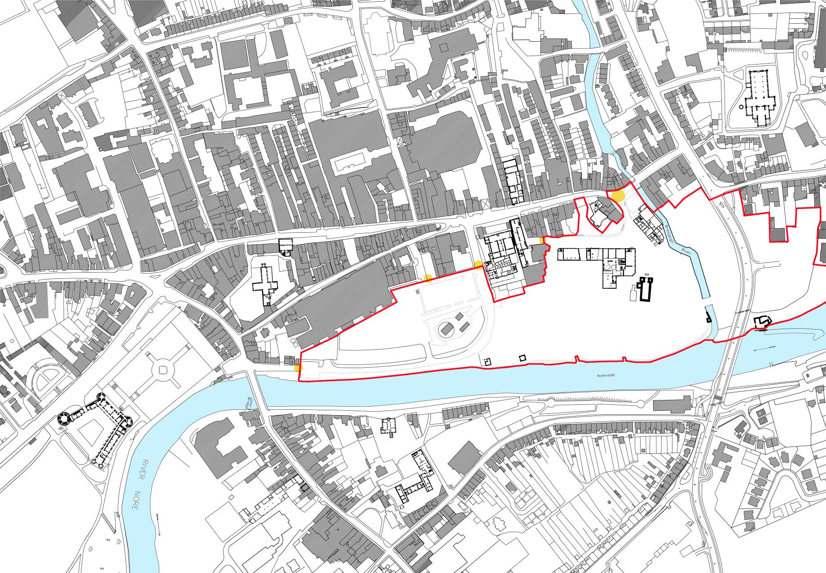
Access points to the Masterplan Area

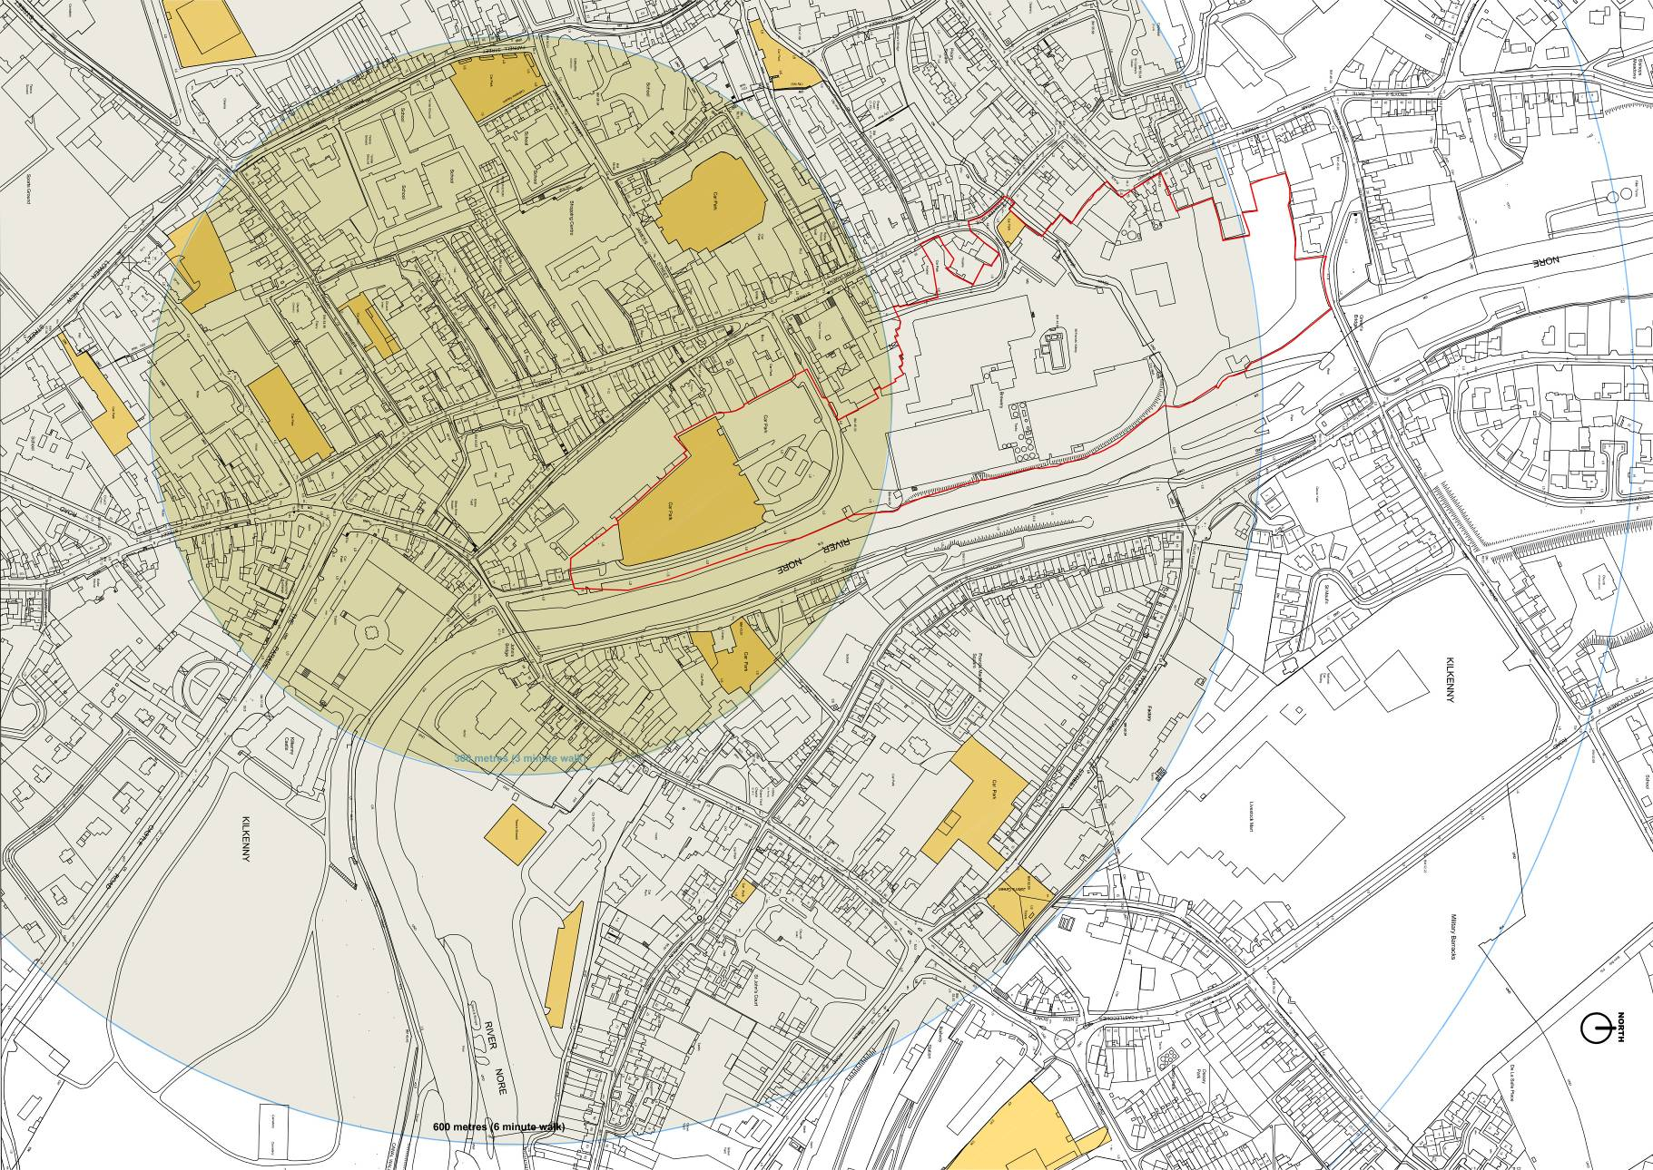4.1.6 Parking / Traffic Management
City Plan with Walking Distances from city centre and location of existing public car parks highlighted.

Within the city centre public car parking is provided both on and off street. Car parking inventories carried out indicate that there are currently approximately 1,400 free or daily rate parking spaces within or on the periphery of the city centre. Typically public car parking within the city centre is reserved for short-term parking, which is subject to a tariff system.

Limited new car parking will be provided within the Masterplan area, primarily for loading/unloading and for mobility impaired drivers. Options for the provision of additional off site car parking facilities, within a short walking distance of the Masterplan Area will be considered.

Kilkenny City Public Carparks
Existing Public Car park

300 metre Zone (3 minute walk)
600 metre Zone ( 6 minute walk)

