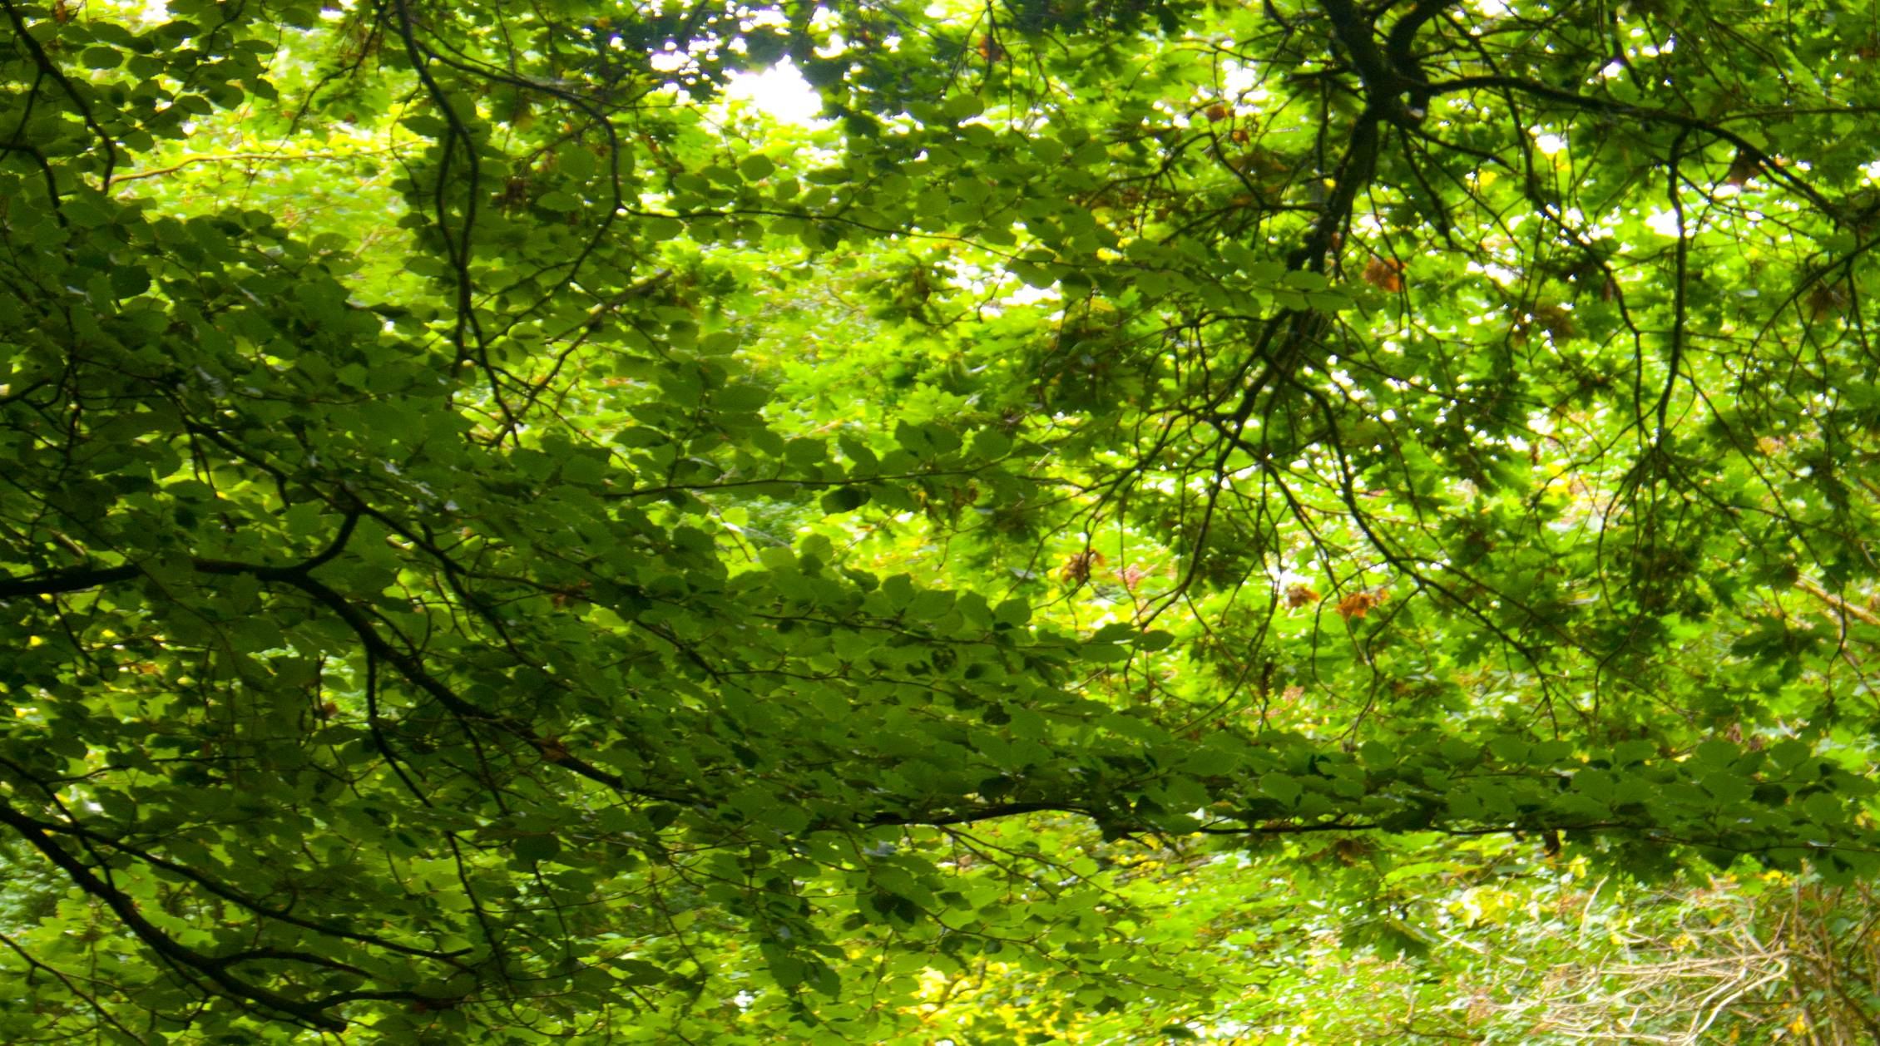

**4.4**

Sustainability

4.4.1 Sustainability Strategy

4.4.2 Density and Mixed Uses

4.4.3 Transport

4.4.4 Environmental Quality

4.4.5 Energy Strategy

4.4.6 Zero Brown Waste

4.4.7 Water Conservation

4.4.8 R&D Funding

4.4.9 Exemplar Developments

**4.4.1 Sustainability Strategy**

The sustainability strategy proposed will be in line with the National Sustainable Development Strategy of the Government of Ireland, The Southeast Regional Planning Guidelines 2010-2016 and the Kilkenny City & Environs Development Plan 2014-2020

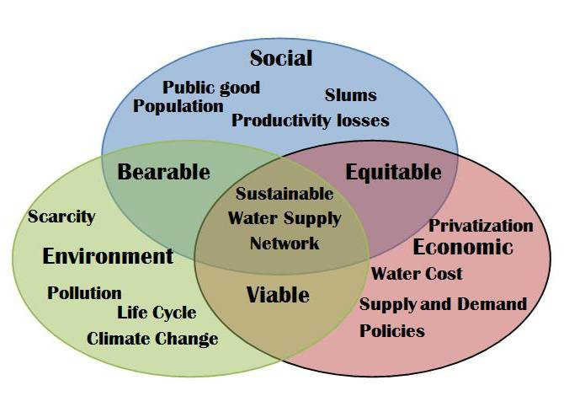

**4.4.2 Density and Mixed Uses**

This masterplan aims to expand the city centre and provide for mix of uses reducing urban sprawl and expansion in line with Section 3.2 and 3.3 of the City & Environs Development Plan. The Masterplan promotes mixed use development with close proximity of housing, jobs, services and amenities. Development should create an attractive and vibrant environment that appeals to a wide range of people.

The mix of uses should allow for synergies to be established between them. The density of the scheme should be compatible

with the existing density of development in the retail core.

**4.4.3 Transport**

The master plan seeks to strike a balance between the need for good vehicular access whilst promoting reduced dependency on the private car and increased use of cycling, walking and public transport. The density and mixed use envisaged for the area will reinforce the idea of the compact city for Kilkenny in keeping travel distances between homes work and other services to within the ten minute city concept.

**4.4.4 Environmental Quality**



The masterplan seeks to develop a high quality and sustainable environment within the Abbey Quarter. This will be achieved within the energy and water management for the area.

**4.4.5 Energy**

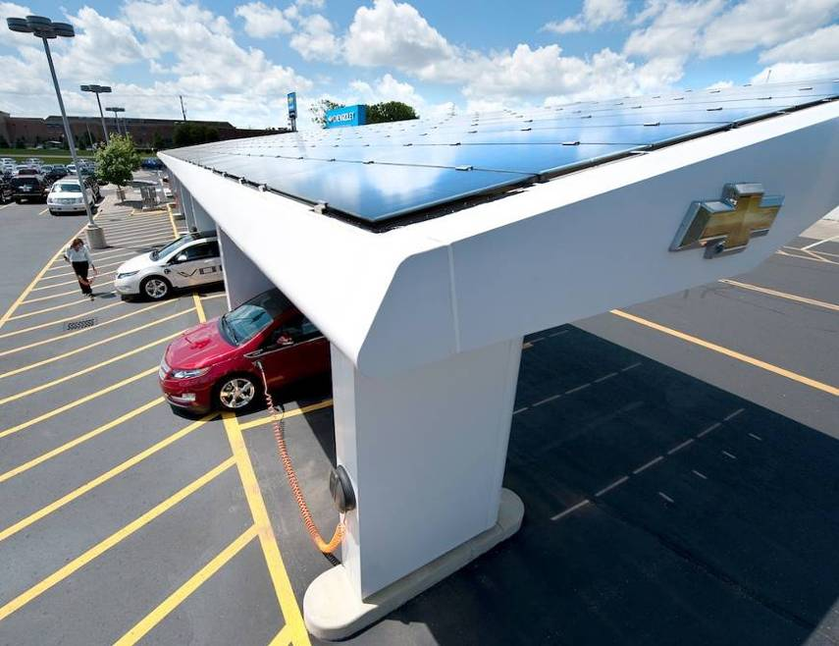

Strategic Objectives to achieve Net Zero Energy Green Zone as an Exemplar Urban Redevelopment model.

The redevelopment of an urban brownfield site presents a unique opportunity to create an exemplar low carbon urban centre that will extend through the existing network and infrastructure. This site has the potential to provide the economic, sustainable and climate friendly stimulus towards a truly sustainable urban centre.

In the development and maturing of this site the opportunities for Research and Development in the green smart economy cannot be underestimated in terms of job creation.

In moving towards these objectives, the Local Authority will propose and implement holistic problem-solving approaches, integrating the most appropriate technologies and policy measures. This will incorporate ambitious and pioneer measures in buildings, energy networks and transport.

Section 9 of the Kilkenny City & Environs Development Plan sets out in detail the Energy Objectives for the city.

**1) Net Zero Energy / Carbon Neutral Site**

a) Passivhaus Standards for all New and Old Buildings on Site ranging as low as 15kWh/m2 for all buildings. (reference La Confluence Site – Paris) – Each building owner contracted at the time of site purchase or lease will be required to achieve Passive standard as an absolute requirement in construction.

i) New buildings with net zero energy requirements or net zero carbon emissions when averaged over the year by 2018, thus anticipating the requirements of the recast Directive on the energy performance of buildings (EPBD). This requirement could be anticipated (e.g. 2012) for all new buildings of the local public authority (city).

ii) Refurbishment of the existing buildings to bring them to the lowest possible energy consumption levels (e.g. passive house standard or level of efficiency that is justified by age, technology, architectural constrains) maintaining or increase thermal performances and comfort. This would include innovative / natural insulation material (solid insulation, vacuum insulation, vacuum windows, cool roofs, living roof space etc.)

b) Integrate renewable heat and electricity generation and export potential in site development with site becoming a net exporter of heat and electricity.

**2) Energy Strategy**

An energy strategy will be developed for the Masterplan area. This strategy will consider the following principles:

a) Demand Side Management:

i) Smart grids, allowing renewable generation, electric vehicles charging, storage, demand response and grid balancing / stabilisation on site.

ii) Smart metering and energy management systems domestically and commercially.

iii) Smart appliances/services (ICT, domestic appliances), lighting (in particular low energy solid state lighting for street and indoor), equipment (e.g. motor systems, water systems/waste pumping systems designed to Triple-E standards etc.)

b) Heat & Cooling Supply

i) District Heating network powered by innovative and cost effective biomass, solar thermal and heat pump applications – allowing for the uptake of the Renewable Heat Incentive tariffs programmed in DCENR for 2017 and beyond.

ii) Innovative hybrid heating and cooling systems with advanced distributed heat storage technologies.

iii) Highly efficient co- or tri-generation centralised CHP utilising renewables where feasible (Biomass, BioGas, Solar Thermal)

iv) Install district heating Network that delivers connection point to each serviced site location Heat pumps from

(a) River

(b) Sewerage System

v) Ground Source Install solar thermal roof panels to allow individual building owners to export excess hot water to the DH network.

vi) Install other communal facilities planned in the buildings to include capturing heat from warm grey-water to pre-heat hot-water tanks. Greywater is collected from showers, washing machines and washbasins; and then, once biologically treated and cooled, it can then be used for watering.

c) Electrical Energy Supply

i) Positive site generation – foster local Renewable Energy Supply (RES) and trading and envision the site as a future Net Exporter to Other Areas of Urban Space

ii) Hydro power for Renewable Electricity from River Nore.

iii) Install smart grid network in utility service delivery package to allow buildings to export excess Photovoltaic Solar energy into network generated from Rood top/Brie-soleil’s solar generators.

iv) Lead to potential to expand energy supply network to the older developed areas of the city along existing service network routes.

**4.4.6 Zero Brown Waste Site**

a) All brown bin waste will be recovered

b) Rainwater recovery.

c) Brown Water reuse for non- potable uses.

**4.4.7 Water Conservation**

The specifications for buildings should encourage architects to prefer methods that save drinking water; and encourage the public- and greenspace designers to address the water-management issue at a very early stage. In this district, saving water should be approached holistically, both inside and outside of buildings.

The public spaces that feature vegetation will be designed to be water-frugal and able to incorporate rainwater-harvesting systems. The aim will be to limit watering by selecting appropriate tree and plant varieties; and to supply them with water from rainwater stocks. And also to limit the flood risk by avoiding too much impermeable ground.

Excess rainwater will be conveyed via channels and released into the River Nore. These channels restore rainwater to the natural environment while limiting pollution, as slow natural filtration takes place en route.

Details of this proposal will need to consider the potential for adverse effects on the ecology of the River Barrow and Nore cSAC and the River Nore SPA as required under Article 6 of the EU Habitats Directive.

**4.4.8 R&D Funding and EIB Funding Opportunities**

Options for the funding of the research and development of the energy strategy for the masterplan area will need to be identified and considered.

**4.4.9 Exemplar Urban Developments:**

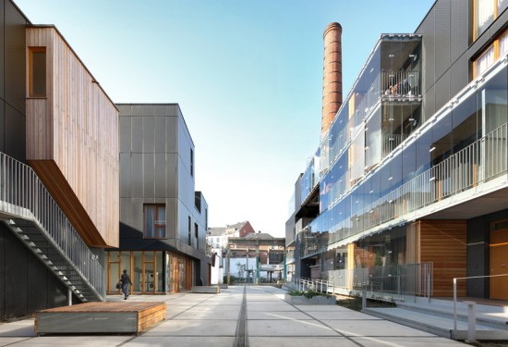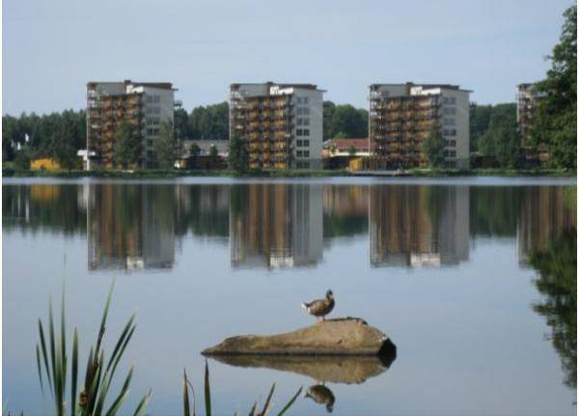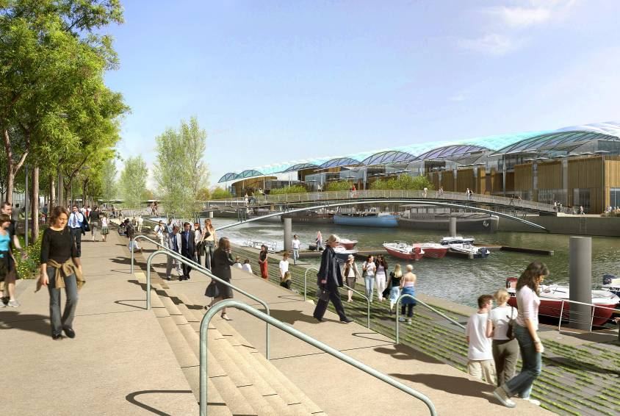

The following is a bibliography of examples of similar type European developments:

* http://www.wbarchitectures.be/en/ architects/MDW_ARCHITECTURE/Savonnerie_Heymans/454/

which is in the middle of the old centre and it was previously a soap factory

* http://www.lyon-confluence.fr/en/index.

html which is in the in the middle of the centre of Lyon- in the past, you were able to find the jail and wholesale markets.

* <http://www.archdaily.com/164519/chevalnoir->

housing-with-artists-studios-lescaut-ateliergigogne/ which was previously the Hallemans breweries

* <http://www.molenbeek.be/fr/la-vie-amolenbeek/> espace-public/contrats-de-quartiers (in French or NL) in Brussels – there are working neighbourhood / neighbourhood –phase 3
* www. molenbeek.be/fr/la-vie-a-molenbeek /espacepublic/ contrats-de-quartiers /fichiers / 066CQLEO_dossier PH3_FRopt.pdf and phase 1 & 2 :
* www. molenbeek.be/fr/la-vie-a-molenbeek/espacepublic/ contrats-de-uartiers/fichiers/CQLEO_dossierphase12_FR.pdf
* Hammerby Sjostad – Stockholm [www.hammarbysjostad.se](http://www.hammarbysjostad.se)
* Wels – Austria
* Vaxjo – South East
* Tralee – Ireland