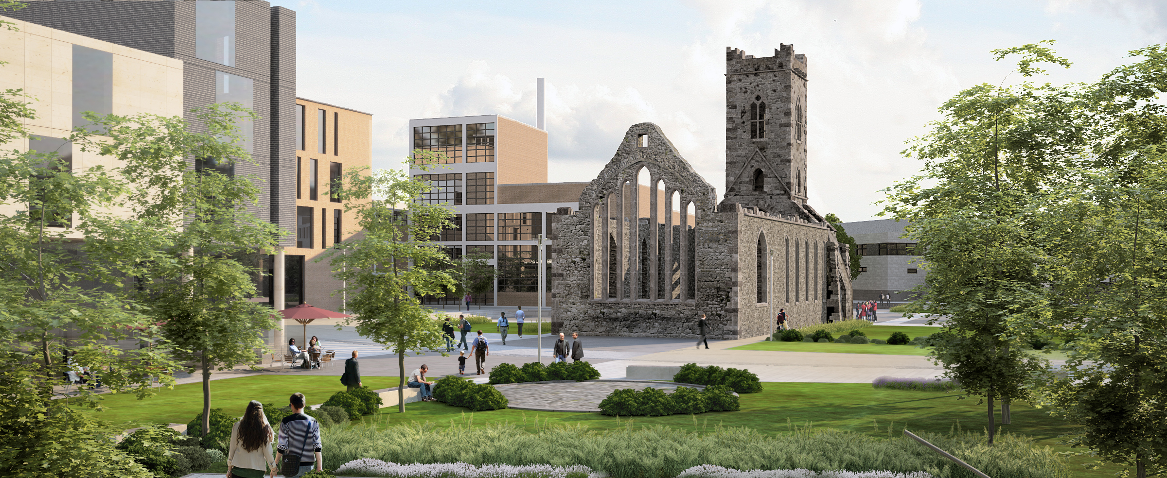

5.1
Establishing a New Quarter

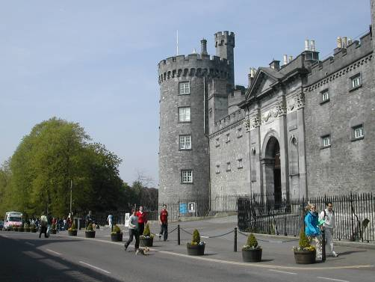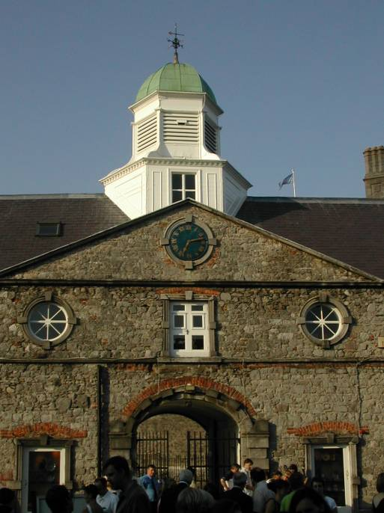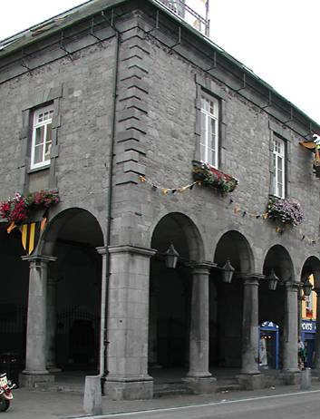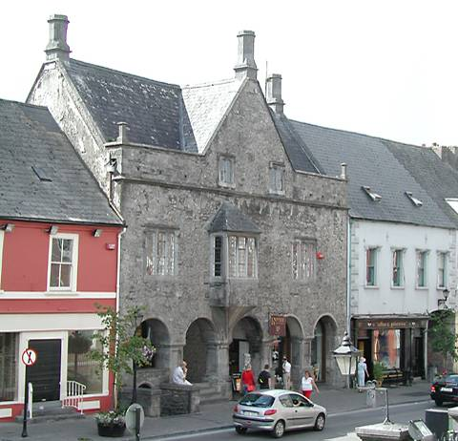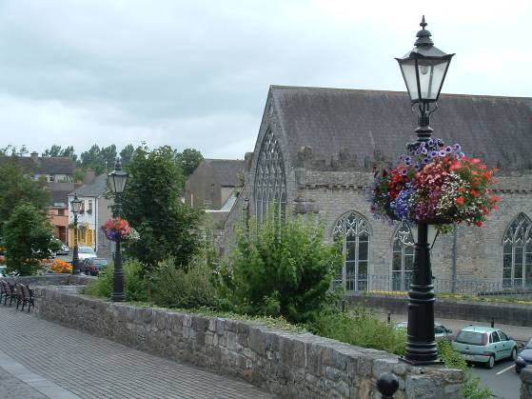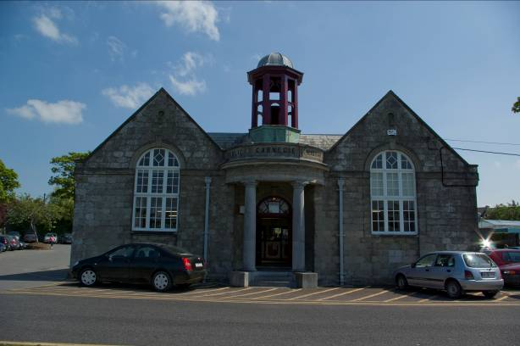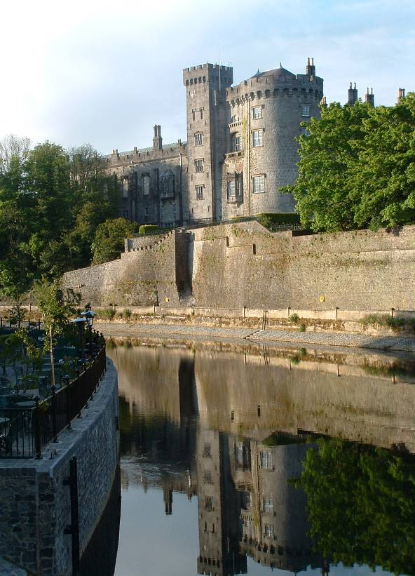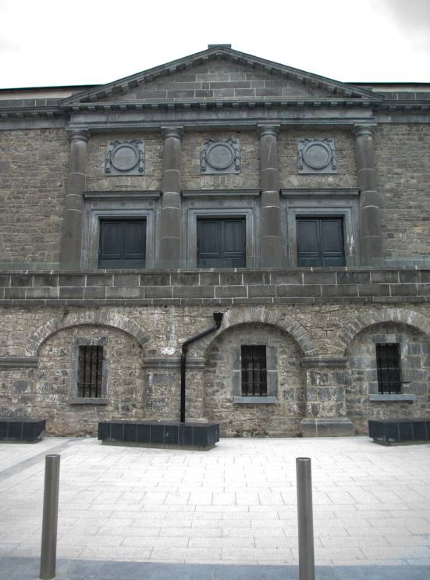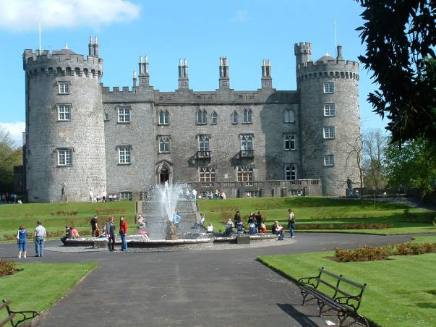5.1.1 Defining a new role for the Quarter

This site offers a unique opportunity to create an entirely new and viable city centre quarter, based on education, innovation, culture , residential, and employment. It also offers the challenge of extending a medieval city in a manner that is both contemporary and forward looking, whilst also contextually sitting comfortably within the site setting of archaeological and industrial monuments.

5.1.2 Integration of site into the existing Medieval fabric

The stitching of the Brewery site into the existing medieval city is a complex task, where due consideration must also be given and appreciation to the validity of the industrial heritage of the site as an important aspect of the historical evolution of the city. The proposed long term retention and renovation of the Brewhouse Building is an important part of this process, and its juxtaposition alongside St. Francis Abbey and the space between the two buildings, when developed as a public open space, will demonstrate the long and varied history of the site.

5.1.3. Links to the Historic Spine / Medieval Mile

It is evident that Kilkenny city has an imbalance of economic activity, gravitating around the Parade and Castle. The development of the St Francis Abbey and Bateman Quay site has the potential to open up
the entire north-eastern quarter of the city, and to attract new businesses, tourism and residents back into the city and improve the overall perception and success of the city. Thus benefiting all areas.

5.1.4 Public Open Spaces

The architectural character of a city is determined not only by the importance of individual buildings and groups of buildings but also by the quality of the spaces formed by the buildings i.e. the footpaths, streets, squares, parks, views and vistas.

The public spaces in Kilkenny are many and varied, from the grand civic space of the Parade to the many smaller and incidental spaces and the numerous streets and slipways of the medieval city. Primarily the new public spaces proposed relate to the provision of new appropriate settings for the numerous existing heritage structures within the site.

