The anticipated study area for the scheme is outlined below but this may be amended as the scheme progresses. Some items such as river surveys will extend beyond this area

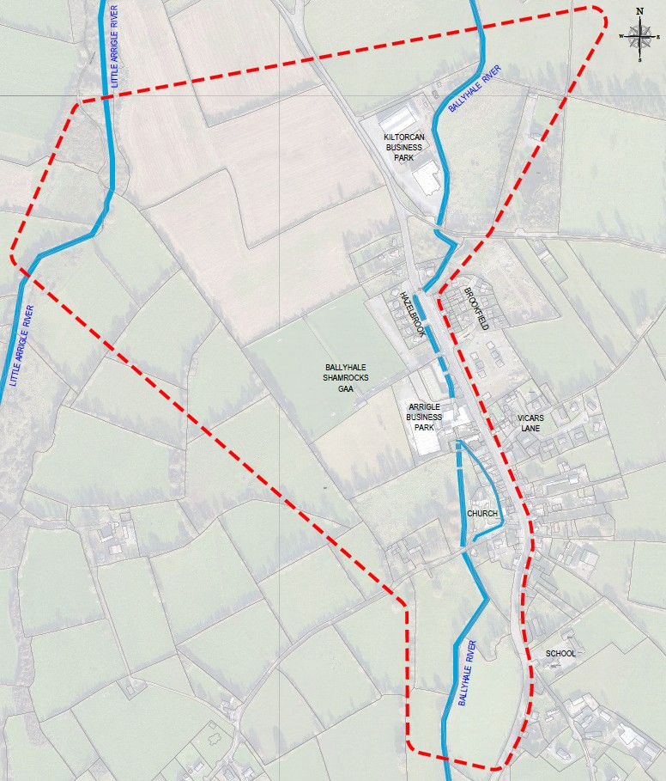
Primary Study Area

